**<Technology Simplification Accounting hub (TU244)>**

|  |  |
| --- | --- |
| **RTC Project Reference No.** | 186898 |
| **RTC Design Reference No.** | 186903 |
| **Owner** | <Sarit Seal> |
| **Author** | <Sarit Seal> |
| **Version** | 0.2 |
| **Approval Date** |  |

Document Revisions

| **Date** | **Author** | **Role** | **Version** | **Comments** |
| --- | --- | --- | --- | --- |
| 12/06/2014 | Sarit Seal | Solution Architect | 0.1 | Draft |
|  |  |  |  |  |

Document Contribution

| **Date** | **Name** | **Role** | **Version** | **Contribution** |
| --- | --- | --- | --- | --- |
|  | Sarit Seal | Application Architect | 0.1 | Author |
|  | Ajay Dash | Infrastructure Architect |  |  |
|  | Naresh Buch | Information Architect |  |  |
|  | Renju Damodaran | Security Architect |  |  |
|  |  | Enterprise Architect |  |  |

Distribution List

| **Date** | **Name** | **Role** | **Version** | **Reason for Issue** |
| --- | --- | --- | --- | --- |
|  | Deshdeep Saxena | Business Analyst |  |  |
|  | Alister Lees | IT Project Manager |  |  |
|  | Ankit Somani | ADM Subject Matter Expert <Account Master Data> |  |  |
|  | Wayne Ramsey / Kirstie Elliot | ADM Subject Matter Expert <IF-TD01> |  |  |
|  | Nick Simon-Norris | ADM Subject Matter Expert <IF-Lynx> |  |  |
|  | (via Fraser Lyle) | ADM Subject Matter Expert <IF-Midtier> |  |  |
|  | Isabel Taggart / Peter Niccol | ADM Subject Matter Expert <NCA and wCBS> |  |  |
|  | Wayne Ramsey / Kirstie Elliot | ADM Subject Matter Expert <TD01> |  |  |
|  | Anshu Maheshwari | Quality Assurance (Functional) |  |  |
|  | Anshu Maheshwari | Quality Assurance (Non-Functional) |  |  |
|  |  | Release Manager |  |  |
|  | Martin Allen | SD Infrastructure Solution Manager |  |  |

Table of Contents

1. Project Summary 6

2. Architectural representation 7

2.1 System Context Diagram: As-Is 7

2.2 Systems Context Diagram: To-Be 7

3. Requirements View 8

3.1 Functional Requirements 8

3.2 Non-Functional Requirements 8

3.3 Business Impact Assessment (BIA) 9

3.4 Architecturally Significant Use Cases 10

4. application view 11

4.1 Outline Application View 11

4.2 Detail Application View 11

4.3 Sequence Diagrams for all Use Cases 11

5. Data View 12

5.1 Outline Data Elements 12

5.2 Detail Data Elements 12

6. Infrastructure View 13

6.1 Outline Infrastructure Elements 13

6.2 Detail Infrastructure Elements 15

6.3 Environment Overview 20

7. Cross-Cutting views 21

7.1 Security 21

7.1.1 Security Domain Impact Analysis 21

7.1.2 Security Model for Impacted Domains 21

7.2 Identity Management 23

7.3 Application Security 25

7.4 Fraud and Financial Crime 27

7.5 Information Privacy 28

7.6 Compliance 29

7.7 <Other Cross-Cutting Views as Required for the Project> 30

8. Architecture Decisions 31

9. Appendices 32

9.1 IT Application Landscape Overview: Application Change Inventory 32

9.2 Compliance with Lloyds Banking Group Policies and Regulatory Requirements, IT Policies, Standards and Patterns 33

9.2.1 Compliance with Policies, Regulations, Standards and Patterns 33

9.2.2 Group Records Policy Compliance 33

9.3 Known Architecture Risks, Assumptions, Issues and Dependencies 34

9.3.1 Risks 34

9.3.2 Assumptions 34

9.3.3 Issues 34

9.3.4 Dependencies 34

9.4 references 35

**Purpose of the document**

The Architecture Description is a deliverable that is produced after the Detail Architecture Elements activities in the Group’s High Level Design process. It uses several architectural views to depict different aspects of the system. It defines the required components, their interfaces and the nodes on which they will execute so that development and configuration of the system can begin.

It is produced when the architect deems that the artefacts are sufficiently detailed to pass to Application Development and Maintenance (ADM) and Service Delivery (SD) for build and test.

This document is an extension of the earlier E2E document (Accounting hub for TBT SOC approved on 17th Dec 2013) produced for Accounting Hub Phase1 and Phase 2. Reasons for creating a new document

1. Align to the industrialized design process
2. Align to the Posting requirements from the hHBOS Payment engines. The Payment traffic will be routed to the Lloyds Payment engines, and will be posted to wCBS, IF-TD01, IF-Lynx, TD01, NCA
3. Align to the revised accounting model which includes settlement/contra NPA’s on rCBS accounts while the customer accounts remains in the hHBOS platforms.

Posting to NCA, is to enable posting to accounts such as Sainbury’s which will be removed by subsequent project

Batch Postings to hHBOS platforms. Batch files will be generated by Accounting hub for the hHBOS platforms.

Accounting hub will also receive Batch files from the Payment engines for Paper clearings and potentially BACS, and it would generate the posting files for each product platforms.

# Project Summary

Technical problems was experienced by the Royal Bank of Scotland Group (RBSG) in mid 2012, Following the problem Group Operations Risk, supported by Group IT, initiated The IT Resilience Review with the purpose of identifying the IT resiliency of LBGs Critical Business Processes (CBPs). Price Waterhouse Coopers (PwC) was invited to conduct an independent review of the IT resiliency of LBG’s CBPs and identified 36 CBPs categorised as either Category A, B or C with different availability and recovery time objectives across 19 key themes. One of the key themes was Age and Complexity and this project is one of a number that will reduce the resilience risk associated with the identified CBPs.

This project is required as an enabler for up to 5 other projects within the Age & Complexity theme - CHAPS, Faster Payments, International, cheque and credit In Clearing and BACS projects. All projects were identified in the Technology Simplification Initiative's scoping phase and are specifically in the Payments (Routing) area. The direction is the Payments engines in the HBOS legacy will be decommissioned and the traffic will be routed to the Lloyds Payments engines (a.k.a LCS, STP etc). As per strategy Payments engines will not directly send the postings to the hHBOS product platforms, rather the postings and enquiry requests will be mediated through Accounting hub. Hence the interfaces to the product platforms are being built in Accounting Hub.

The strategy is to use Accounting hub as a facade for the product platforms both for account enquiry and account posting. To the external consumers. It also acts as a gateway to the product platforms as it hides the complexity of the consumers, schemes, and transactions. This strategy benefits the programme by abstracting the payment engines from the product platforms. Hence there is a potential case of re-use. The programme benefits through economies of scale.

Accounting hub will be delivered as part of TMH Release 4 and release 5.1 into production. This release will deliver the capability to post to rCBS and provide enquiry facility for rCBS, CAP and Common System accounts.

The scope of this project is to build the interface to the HBOS product platforms. The interface built will be a generic interface to the product platforms. The actual posting entries will be decided by the payment engine projects which will use Accounting hub capability to post to these product platforms. The guideline is to keep the design generic for it to accommodate accounting models based on the current FPS accounting model for accounts on hHBOS.

As per the HBOS decommissioning project under Technology Simplification Age & complexity the scope is to decommission the hHBOS Payment engines and route all the inbound and out-bound payments through the Lloyds payments engines. The Lloyds Payment engines (aka LCS, Common System, STP) will use Accounting hub to identify the product platform, and will route to accounting hub for posting to the hHBOS product platforms. The primary guideline is to reuse the existing interfaces on the hHBOS platforms this approach reduces development on the fated systems.

# Architectural representation

This section describes, at a high level, the current system and how the solution will meet the requirements for the new system. It bounds the scope of the system to be constructed or changed and identifies the scope of change to be delivered by the project. It provides a quick insight into system-to-system integration changes that this project will need to deliver.

## System Context Diagram: As-Is

The current system context does not include accounting hub. The system in context is accounting hub it does not exist in the current architecture. As per the current implementation the payment engines connect directly to the accounting platforms for Posting and enquiries. ALS plays an important role as it is used to identify whether the account is migrated to Lloyds or is an unmigrated account residing in the hHBOS product platforms. *The current system context does not include Accounting hub. The Payment engines make postings to the Product platforms directly.*

This diagram must be provided if an existing business process or application(or both) is being changed. See Hint and Tip RSA Diagrams – Copying or Saving.

Output the System Context diagram from RSA/RRC and insert as a picture. The diagram should be depict the boundary between what is to be constructed or amended (or both) and:

* The human actors who will interact with the system (both business and IT)
* The system actors with which the system will interface and which are outside of the project’s scope

## Systems Context Diagram: To-Be

This diagram must be provided for all projects. See Hint and Tip RSA Diagrams – Copying or Saving.

If an as-is diagram has been provided then

The following context diagram depicts the to-be system context. The system in context is the Accounting Hub.

Core capabilities to be delivered as part of this project is the connectivity to the hHBOS product platforms. These interfaces will be both batch and online.

The accounting model pattern is based on the FPS model used today. The FPS model sends the customer advices to the hHBOS platforms while it sends a settlement entry to rCBS. The design does not constrain on the accounting model patterns. In order to integrate with the hHBOS platforms. Accounting hub needs the account posting entries, however the actual entries is out of scope for this project. The payment projects under resilience or otherwise will be responsible to create / document and get the required approvals for the accounting models. Additionally these posting entries will be loaded in Account Master Data (AMD) within the scope of the payment scheme projects. (Ref: Dependencies 🡪 )

Accounting hub will maintain some additional reference data. These will be used to populate the message before sending to the product platforms.

Note: Throughout the document the message will be used to refer both for files or individual messages. For files secured C:D will be used to transfer the files to the hHBOS platforms. The online interface will be delivered through messages sent over MQ.

This is an extension to the design and the code delivered for accounting hub as part of TMH release 4 and 5.1

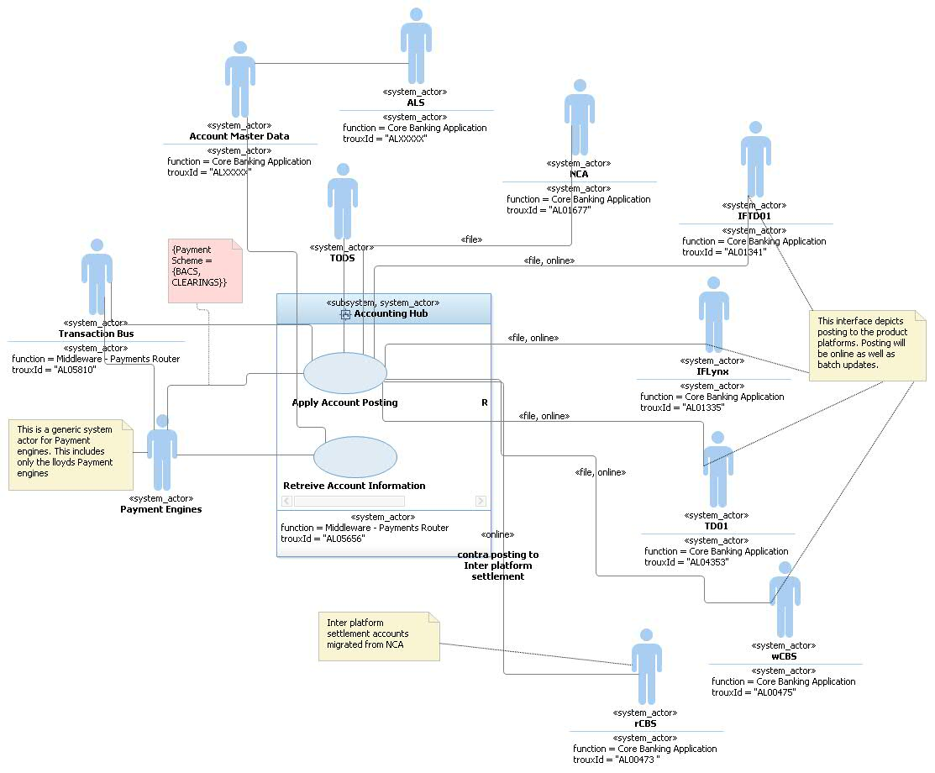

| No | From System | To System | Description | Data to be exchanged | Complexity |
| --- | --- | --- | --- | --- | --- |
| 1*1* | Transaction Bus | Accounting hub : Apply Account Posting  (online only) | Pass the posting transactions from Transaction Bus to accounting hub. These are real-time requests to Accounting Hub. Accounting Hub will generate the actual posting entries and pass to the product platforms. The responses will be sent to the Transaction Bus. | Transaction bus (FTM) will send the Posting request to Accounting Hub. The message will be based on the IFW format and will be wrapped in a SOAP envelop.  Accounting Hub responds with a response message based on the IFW format and wrapped in a SOAP envelop. This response is for the status of the request | Medium to Low.  This interface will be live as part of TMH release 4.  Data: The inbound message format may undergo a change. The details of the change will be documented in the Accounting hub Interface document.  Security: The MQ Queues will be accessed over a SSLised connection. The message will not be encrypted.  Infrastructure: The solution does not expect any changes on the hHBOS product platforms. The data volumes will remain the same as it is today. The interface mode will remain as-is. |
| 2 | Payment engines  (This is used as a placeholder for postings file sent by Payment engines to Accounting hub) | Accounting hub | There are two possible interfaces:   1. Account enquiry for all hHBOS accounts. The current scope   and batch based Account postings | Account Enquiry – Sort Code + Account Number  Account Postings: Posting entries | Account Enquiry: None  Account Posting: High. The file processing service needs to be built |
| 3 | Accounting hub: Apply Account Posting | Account Master data | Identify the product platform by sort code + account number | This is a SOAP webservice call over HTTPS. The request will contain sort code+ account number while the response will contain the product platform identifier | Proposed change: Account Master data will expose a service to identify the product platform apart from the current functionality covered as part of the Retrieve Additional Account Information  Refer §3.1.1 for more details |
| 4 | Accounting hub: Apply Account Posting | NCA | Posting entries for customer accounts on NCA and settlement entries | This can be both a file and online through NCA. | No impact on NCA.Accounting hub will send the files to NCA router which iturn wwill generate the NCA |
| 5 | Accounting hub: Apply Account Posting | TD01 | Posting entries for customer accounts on TD01 for all payment schemes | This will be both file and online. For example CHAPS will be a MQ message, while for international it will be files | No impact on TD01.  CHAPS: Accounting hub will have to generate MQ messages for TD01 Online to consume  BACS and International will be files |
| 6 | Accounting hub: Apply Account Posting | wCBS | Posting entries for customer accounts on wCBS for all payment schemes | This will be both file and online.  For example CHAPS will be a MQ message, while for international it will be files | No impact on wCBS.  CHAPS: Accounting hub will have to generate MQ messages for TD01 Online to consume  BACS and International will be files |
| 7 | Accounting hub: Apply Account Posting | IF-Midtier/IF-TD01 | Posting entries for customer accounts on IF-TD01 for all payment schemes.  Send the message to IF-Midtier, and IF-Midtier forwards to IF-TD01 continue as it happens today | This will be both file and online.  For example CHAPS will be a MQ message, while for BACS it will be files | No impact on IF-Midtier and IF-TD01.  CHAPS: Accounting hub will have to generate files for IF-Midtier  BACS and International will be files |
| 8 | Accounting hub: Apply Account Posting | IF-Midtier/ IF-Lynx | Posting entries for customer accounts on IF-Lynx for all payment schemes.  There are two options to be analysed  Send the MQ message directly from accounting hub to IF-Lynx  Send the message to IF-Midtier, and IF-Midtier forwards i to the IF Platforms | This will be both file and online.  For example CHAPS will be a MQ message, while for BACS it will be files | No impact on IF-Lynx.  CHAPS: Accounting hub will have to generate MQ messages for IF-Midtier/ IFLynx  BACS and International will be files |
| 9 | Accounting hub: Apply Account Posting | rCBS | Settlement entries for customer postings for all payment schemes. This can be both individual contra postings or aggregated contra postings | This will be both file and online. | No impact on rCBS. |
| 10 | Accounting hub: Apply Account Posting | TODS | Passes transaction audit information to TODS for recording. This includes both for online and batch transactions | Online | Identify the right activity type on TODS, and MQ impact |

# Requirements View

This section references the project’s use cases and identifies those use cases or scenarios from the use-case model that represent some significant, central functionality of the final solution or that have a large architectural coverage e.g. if they exercise many architectural elements or if they stress or illustrate a specific, delicate point of the architecture.

Provide a reference to the baselined set of functional and non-functional requirements produced in the Requirements Phase. If these have changed since acceptance indicate that and also indicate if they are undergoing any changes – as there will be a risk that the relevant changes to the requirements will impact the design.

## Functional Requirements

The functional requirements related to this Architecture Description can be found here: Accounting Hub will be delivering the following functions as part of this release:

1. Account enquiry for accounts on hHBOS product platforms
2. Availability information for the hHBOS product platforms
3. Account Posting to hHBOS product platforms
4. Account Posting features:
   1. Inter system settlement
   2. Generate Posting files to the product platforms
   3. Aggregate Posting entries before sending to product platforms. Including postings to HOCA Accounts
   4. Process unprocessed messages held in failed nodes.
   5. Generate inter-system accounting to settle between product platforms
   6. Generate multiple transaction groups based on a single posting request
   7. Process incoming posting files and generating posting entries for product platforms.
5. Send posting audit data to TODS <<SERVICE DETAILS TO BE ADDED>>

### Account Enquiry

The following usecase diagram shows the top level usecases to be delivered to support query facility for HBOS postings.

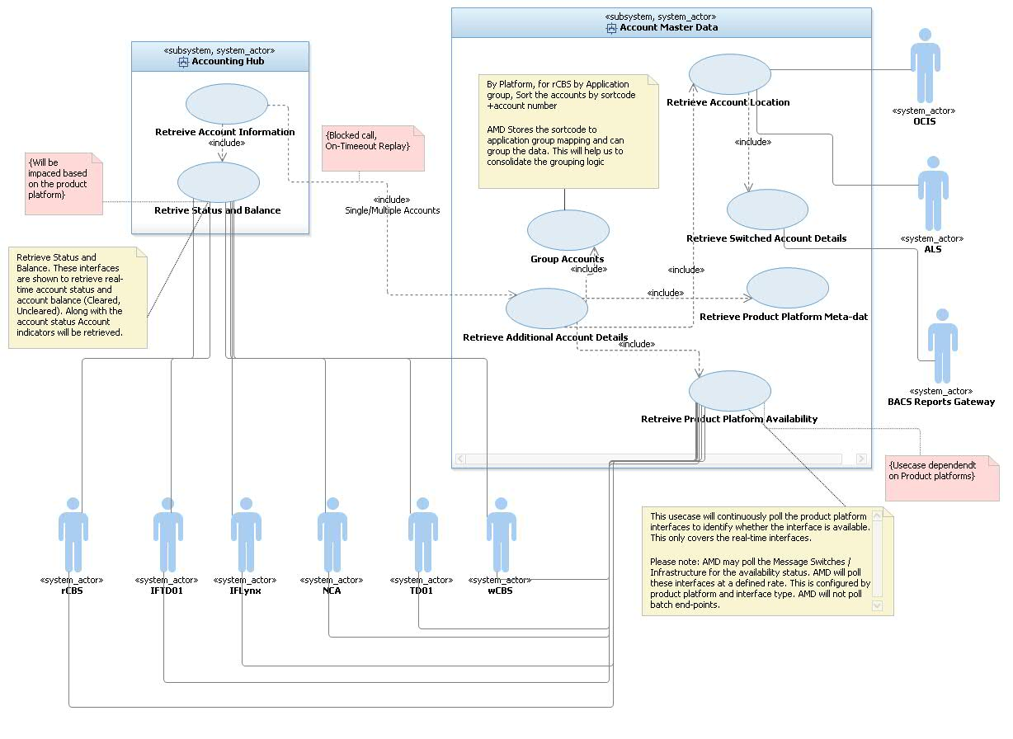

Key points:

1. Account Master Data (AMD) to will be responsible to resolve the product platform for all accounts in the request. Accounting Hub will invoke this service to identify the static data for the account. The benefits/justification is as follows
   1. This approach simplifies the orchestration from Accounting Hub services to invoke OCIS and ALS service.
   2. Account Master Data will cache the calls to OCIS and ALS thus reducing traffic to these platforms. Thus reducing Mainframe MIPS costs. The cache wll be refreshed after the data is refreshed in these Platforms.
   3. AMD to invoke BACS report Gateway to identify whether an account is switched out. The switched out account details will not be used by Accounting Hub for any processing. It will use the sortcode+account number sent as part of the incoming message.
2. Accounting Hub services to connect to the hHBOS platforms for status and Balance. This interface will re-use any existing api/service on the hHBOS product platforms. *Accounting Hub is connected to rCBS, this interface is delivered as part of TMH Release 4.*
3. Account Master Data will have interfaces to the hHBOS platforms to identify whether the platform is available. Accounting hub will use the availability information before forwarding any request to the product platform.
4. All the usecases shown above (except AMD::Retrieve Product Platform Availabilty, and Accounting Hub::Retrieve Status and Balance) will be product platform agnostic. This means these usecases will not be impacted if any new product platform is added. The two usecases mentioned AMD::Retrieve Product Platform Availability, and Accounting Hub::Retrieve Status and Balance will have rules for transformations, validations. Configuration data will be configured for the interfaces on the product platforms.
5. Account Master data will have to load the HOCA accounts file for Corporate and Commercial customers. These HOCA accounts will be maintained within AMD. As part of the Additional Account Information the HOCA account details will be sent to Accounting Hub.

The following diagram shows the logical orchestration for the Retrieve Additional Account details on AMD.

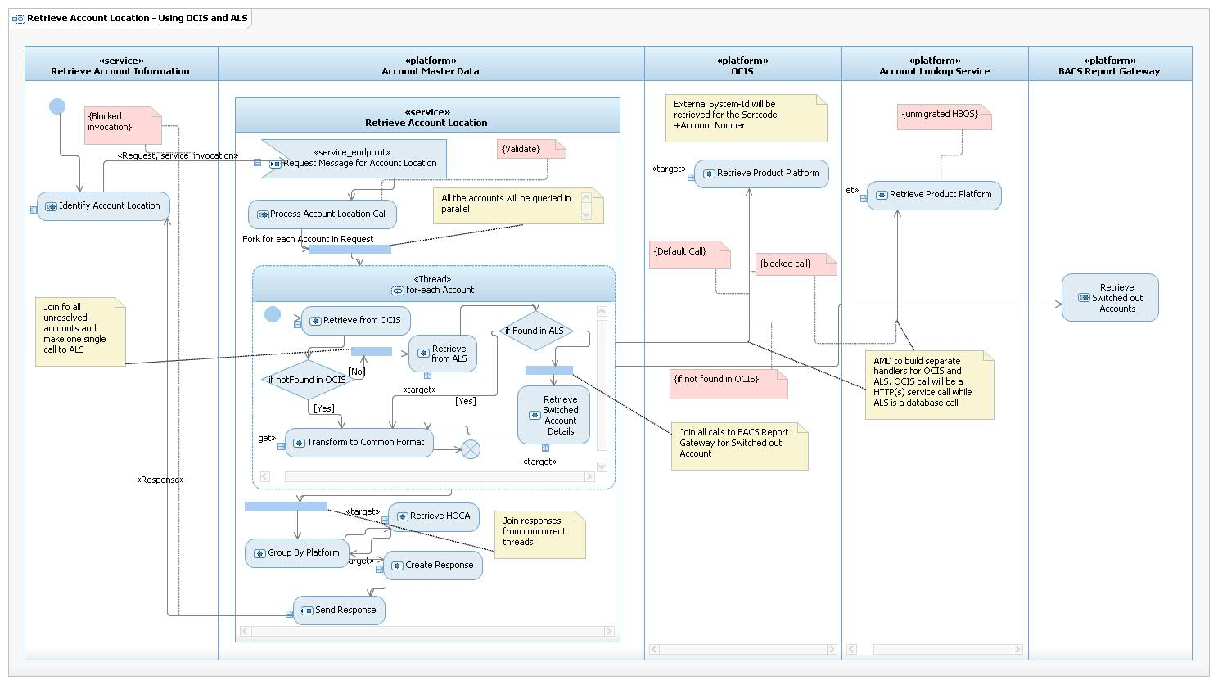

The following diagram shows the logical orchestration for the Retrieve Platform Availability on AMD. AMD will connect to wCBS, NCA, TD01, IF-Midtier to identify their availability. IF platforms will be considered unavailable if IF-Midtier does not respond within a defined window.

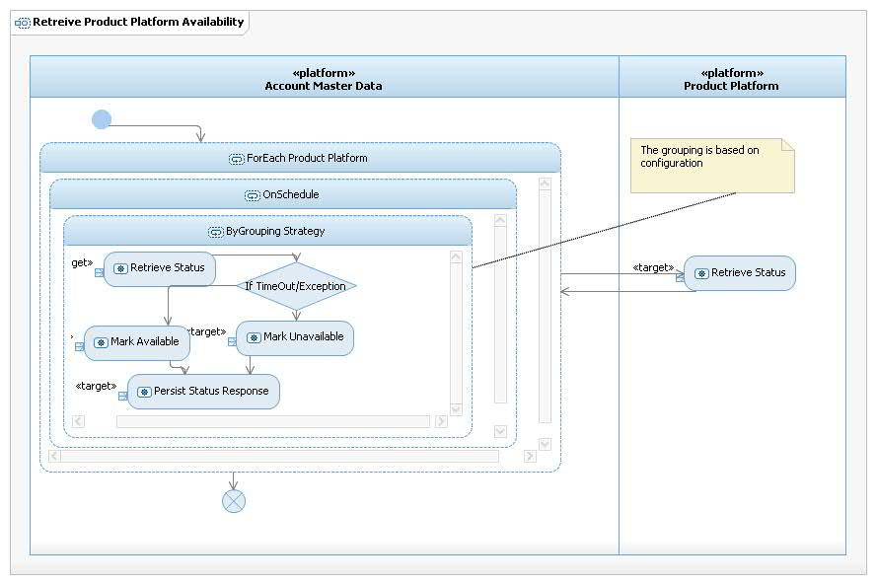

|  |  |  |  |
| --- | --- | --- | --- |
| **Product Platform** | **Application to Host the availability Service** | **Grouping Strategy** | **Interface name** |
| TD01 |  |  |  |
| wCBS |  |  |  |
| NCA |  |  |  |
| IF-TD01 |  |  |  |
| IF-Lynx |  |  |  |

These are the additional interfaces AMD will build to deliver the availability service. If these interfaces do not exist within the product platforms then the availability information will be based on the static reference data stored within AMD for the platform.

Payment projects will drive the need to build the Product Platform availability service

### Account Posting

The following diagram shows the participating usecases required to deliver the account posting service to the hHBOS product platforms. The Account Posting service is being delivered as part of TMH release 4 for TBT SOC. The current Account Posting service posts to rCBS. The limitation of the current implementation are:

1. The service can post to only one platform as part of a single posting transaction. This covers for principal, contra and settlement entries destined for a single platform.
2. The functioning of the service is dependent on the underlying API on the product platform. For example the current rCBS API only allows for the principal Cr/Dr and the corresponding contra. Hence multiple entries for a transaction will have to be sent separately.
3. The current service is for online postings only. It cannot generate a posting file.
4. Creating of aggregated entries from individual posting transactions to be implemented.

The above features are required to implement the posting usecases for hHBOS platforms.

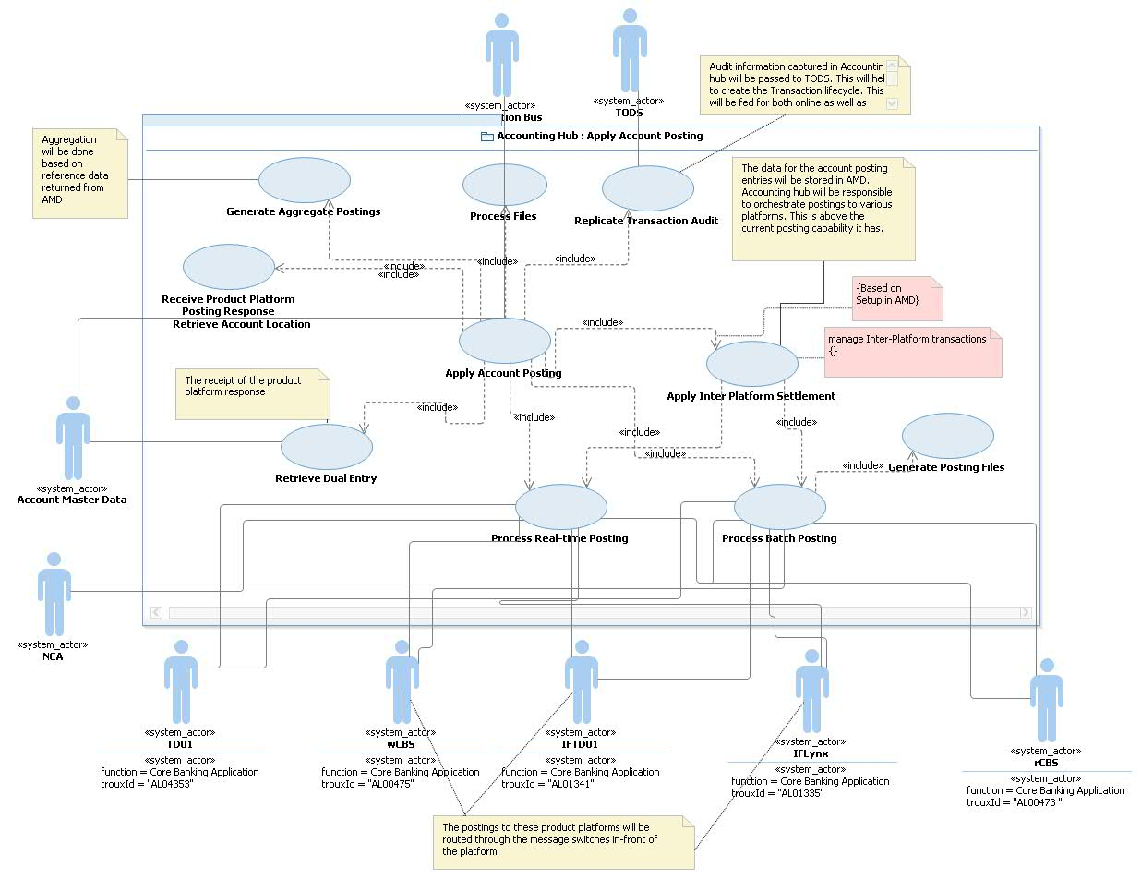

Key points:

1. Accounting Hub will be responsible to resolve the Product Platforms before it sends the postings to the product platforms.
2. If the consumer indicates stand-in in the incoming posting message to Accounting Hub, Accounting hub will provide stand-in capability for customer credit postings. *(The design for stand-in is detailed in the Accounting Hub AD. Link)*
3. Accounting hub will get all the posting entries by scenario from AMD:;GetNPADetails. The data will be configured in getNPA by scenario. GetNPA to provide the following:
   1. Posting entries by Product Platform
   2. Sequence of entries to be passed to a product platform
   3. Posting Mode (online/batch including schedule) and whether the posting is via MQ or a posting file will be generated
   4. Posting Type (Single/Aggregated)
   5. If a transaction involves multiple steps then this service will also send the compensation entries.

These would be added to the current service response. The current service response includes the NPA’s required to send the contra postings. getNPA service will group all the entries by Global Posting Sequence, Product Platform and Posting Sequence Sequence. The sequence would be a combination of two sequences Global Posting Sequence and Posting Sequence to a Product Platform. Based on Global Posting Sequence Accounting Hub will make parallel calls to the product platforms. If a posting fails then Accounting hub will send the compensating entries to the product platforms.

1. Accounting hub to manage inter-system account posting. For example if the current FPS model is followed then accounting hub will have to post the customer postings to the product platforms while it passes the settlement contra (aggregated) to rCBS. Accounting hub will manage the transaction context across these posting entries. Accounting hub will also generate the necessary compensating entries an exception (business/technical) is raised.
2. Accounting hub will send both MQ SOAP, MQ non-SOAP messages to the product platforms to pass the posting entries to the platforms.
3. For postings which are file based Accounting hub will consolidate the entries and generate files (single sided/ balanced) by product platform and application groups wherever applicable. It would generate the necessary contra entries to be posted for inter-platform settlement
4. Accounting hub will maintain the posting entries by scenario and based on the reference data it will post to various platforms. The system will perform based on the reference data and the sequence of execution. This will protect the projects from any change to the accounting models or NPA’s migrating from NCA to rCBS.
5. The scope for posting is for all payment schemes (including IAT) and all account transactions (e.g. charges).
6. For posting to Corporate / Commercial customers requiring aggregated postings, accounting hub will post to the collection accounts as well as aggregate the posting and post to the customer’s account as per schedule
7. The actual data for posting and the compensating entries will be delivered by the Payment engine projects. The entries will be data configured in Account Master Data. The logic to interpret and pass the entries to the platforms will be delivered as part of this project.
8. Audit information for Bulk files will be sent to TODS directly from Accounting hub

The logical orchestration within accounting hub to generate transactions based on response from getNPA is detailed below.

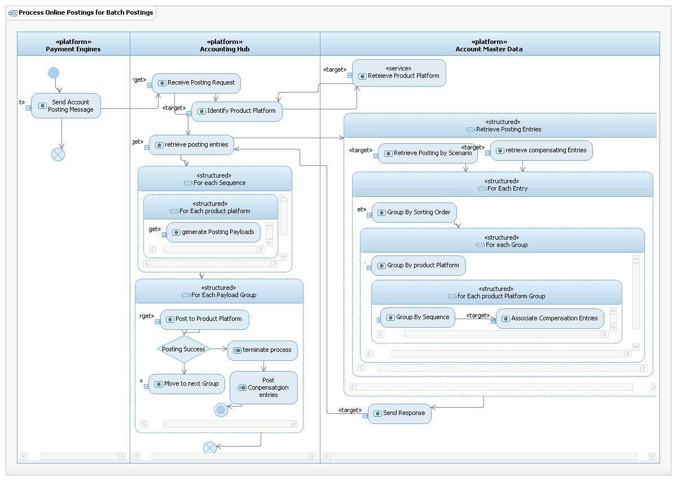

Key steps:

1. Group based on Account Model Sequence / Product Platform / Sequence for Postings
2. Post the entries in the order specified in the above step
3. Make parallel calls based on the sequence defined in step 1
4. If a step fails terminate the process and generate compensating entries
5. If a compensating entry failed then generate alerts.

Each step must have a audit for compensation. Additionally the node which is processing fails then one of the available nodes will pick the message and continue the process.

The entire process will be managed within one distributed transaction context. This will ensure rollbacks are handled gracefully.

If a posting is to be done as files then the data will be logged in a database and retrieved through the Process Batch postings

Manage Transactions Across product Platforms: The following diagram is a logical orchestration within Accounting hub to manage transactions across multiple transactions to different product platforms.

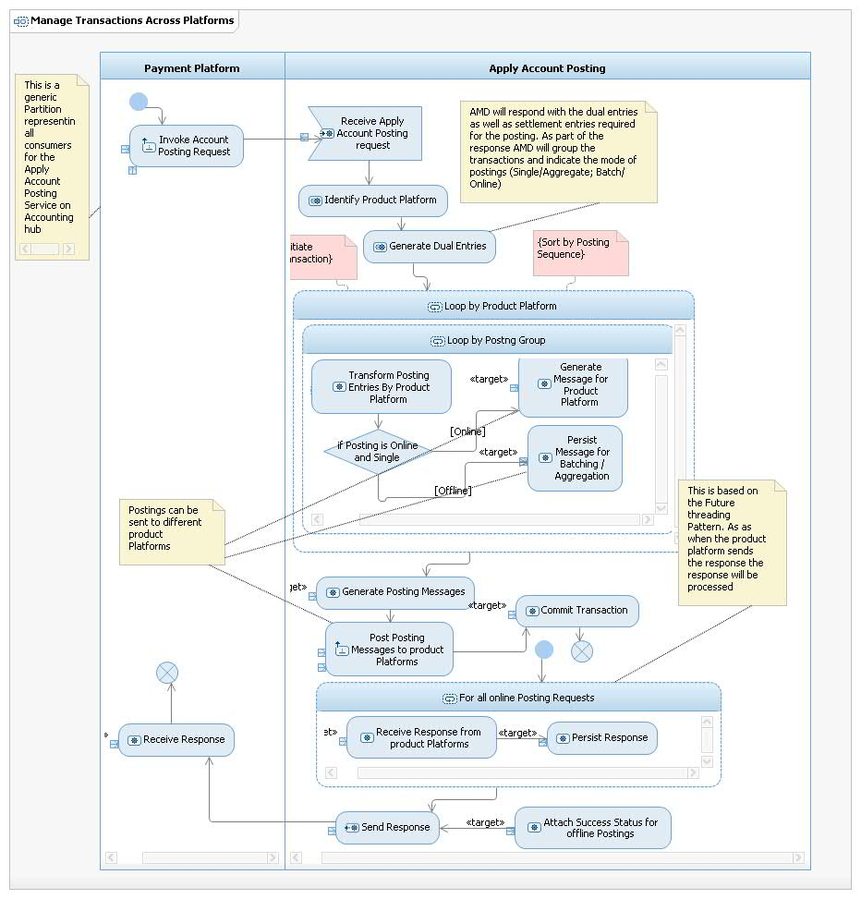

The following diagram is a logical orchestration of the Aggregation Posting flow:

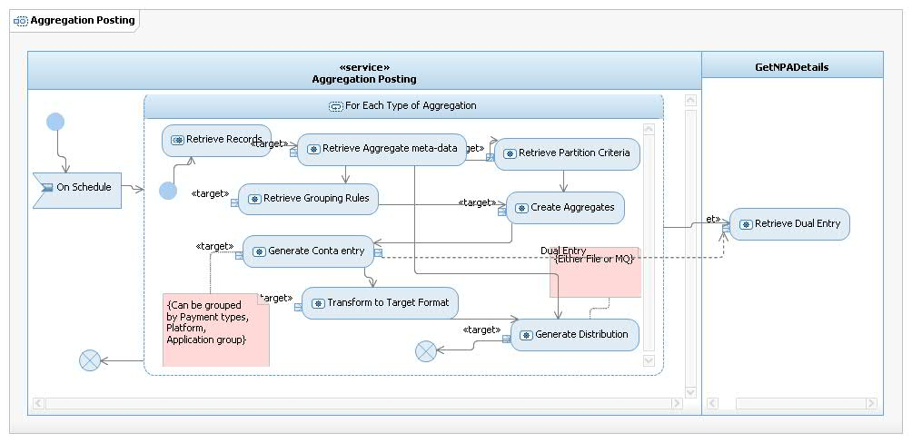

The current Accounting Hub design does not cover for posting messages sent to one Accounting hub Instance. Accounting hub instance has started processing the message and has gone down before sending to the product platform. Once the message is sent to a product platform it can be processed by other available instances. The return flow is simple compared to the request flow as in the response flow the Product Platform message is only transformed and sent back to the consumer.

This scenario although may have a very low probability of happening but is a valid scenario. In order to cover this scenario Accounting Hub will implement a new flow to monitor the transactions stuck and not progressed. Accounting hub will have to audit messages as soon as it reads it from queue. This process will read the audit table for any state changes for that message. If the state change does not happen

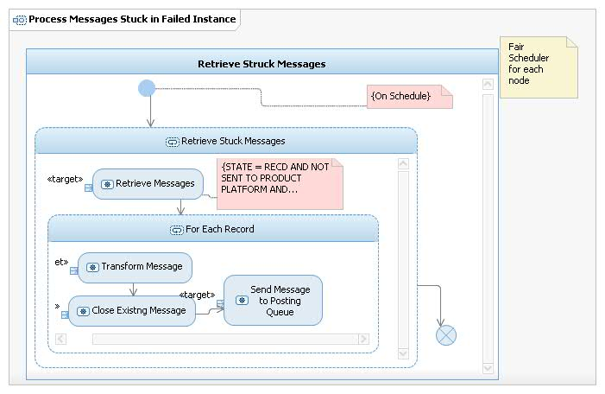

### Generate Batch Posting Files

This is a new capability in Accounting Hub to generate posting files and sending these files to the product platforms. These files can be of any format The file generation is a separate component built within Accounting hub. This component will read the database for the records to be bulked and will generate the file. It can generate inter-platform settlement entries to be passed to rCBS.

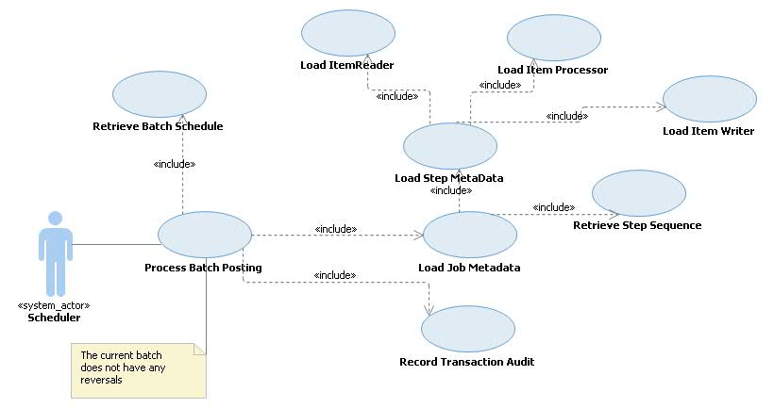

The following set of diagrams shows the logical orchestration for processing entries either as in-bound posting files, inbound message to outbound posting files for product platforms.

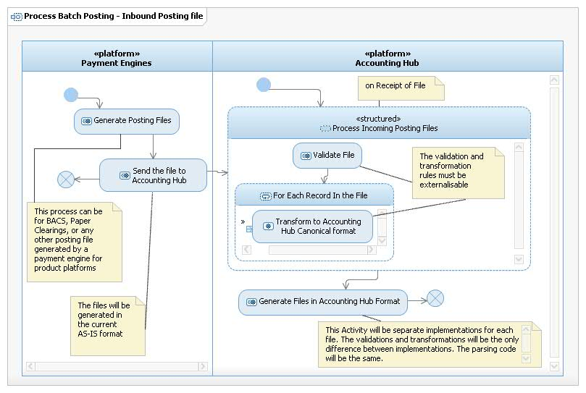

The following diagram shows the logical orchestration for generating the posting file from Accounting Hub. The key components are scheduler, and data retriever, transformer and aggregator.

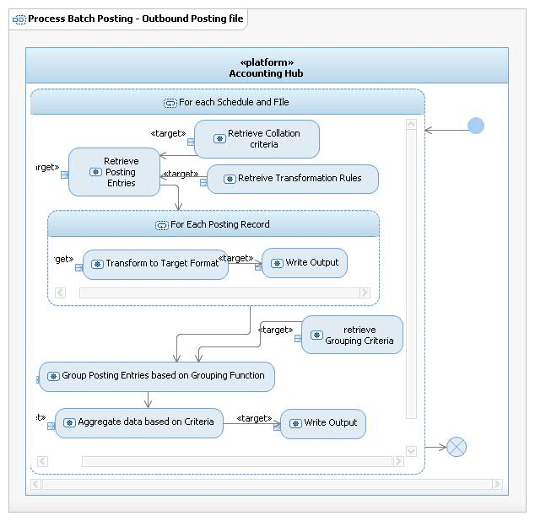



While processing a transaction the call to getNPA will have to be done. (The call to getNPA is omitted from the above orchestrations to keep the diagrams simple). getNPA will return with all the entries needed to be generated. So, in theory based on a posting request multiple postings can be generated. These postings can be sent as files or online messages.

### Manage Posting Reference Data

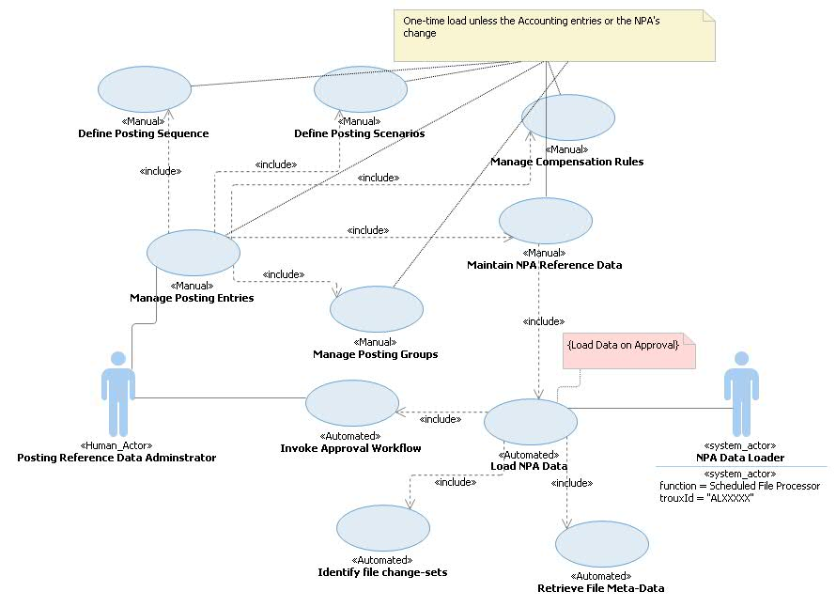

*The stereotypes on the usecases identify whether they are manually or executed through the application. The key system usecase is the reference data loader. This is a batch component and will be used to load the reference data files.*

The usecases defined above are key usecases to be delivered by Account Master data as data-services. The current data service “getNPADetails” will be extended to provide the following information as part of the single call:

1. Posting entries by Payment scenarios
2. Posting mode (file, online) for each of the entries
3. Posting type (single/end-day aggregated/ time-bound aggregation) for each of the entries
4. Entries to be grouped by Product Platform and posting sequence
5. Compensation entries if a posting fails
6. Collection account details

The data needs to be validated before the data is loaded. There needs to be a human approval if any major changes are introduced in the data. Reference data will be stored to indicate the possible number of changes. If the number of changes goes beyond the acceptable threshold the data must be approved before loaded.

Data will be cached and the cache refreshed after the data is loaded/refreshed. All queries must first hit the cache, in case of cache miss the query must reach the database.

## Non-Functional Requirements

All the Non-Functional Requirements related to this Architecture Description can be found here:

The following additional volumes of transactions to be supported:

|  |  |  |  |
| --- | --- | --- | --- |
| Payment Scheme | Account enquiry (day) | Account Posting (day) | Time window |
| International | 800 | 800 | Chaps time window |
| CHAPS | 50 | 50 | International |
| Clearings | 1,00,000 | 1,00,000 | Batch to be posted after midnight |

:

Insert link to RRC project area

## Business Impact Assessment (BIA)

The current BIA for applications impacted by this project can be found on the Data Owner Tracking SharePoint site which can be found [here](http://teamspace.intranet.group/sites/DOT/BIAs/Forms/AllItems.aspx).

The BIA is essential in driving the IT Resiliency requirements of a solution. The following table summarises the main BIA ratings and outlines how this design meets those requirements:

|  |  |  |  |  |  |  |  |  |
| --- | --- | --- | --- | --- | --- | --- | --- | --- |
| **MLS REF** | **Data Owner** | **BIA** | | | | **Aligned Application Name** | **Aligned Troux ID** | **Evidence of how this Design Meets the BIA Requirements for IT Resiliency** |
|  |  | **Confidentiality** | **Integrity** | **Availability** | **Security Classification** |
|  |  |  |  |  |  |  |  |  |
|  |  |  |  |  |  |  |  |  |
|  |  |  |  |  |  |  |  |  |

A separate BIA must be reviewed or created for every application impacted by the solution. BIAs are completed by the business data owner for a business system. N.B. applications may be part of more than one business system, therefore multiple BIAs may be impacted by a solution.

Complete the table by including the Application Name(s) and Application Troux ID(s) that align to each BIA, the BIA ratings and a description of how this design meets the various BIA requirements e.g. how the choice of host platform is driven by the BIA classification as directed within the Infrastructure Hosting Decision Tree standard (published in the EA Reference Library), how an application is architected to run as multiple active-active components.

Note that when making reference to using the Infrastructure Hosting Decision Tree, it is important to state how the selected option meets the resiliency requirements, not just which platforms have been selected.

Confidentiality and integrity ratings are defined as: Critical, Major, Medium, Low and Minor

Availability ratings are defined as: High, Medium, Low and Non-Critical

Accounting Hub BIA can be found in the following link. The Payment projects will perform their specific BIA

. <http://teamspace.intranet.group/sites/DOT/BIAs/MLS3404_TMHAccountingHub_2013.xls>

## Architecturally Significant Use Cases

All the Use Cases related to this Architecture Description can be found here:

### Account Enquiry

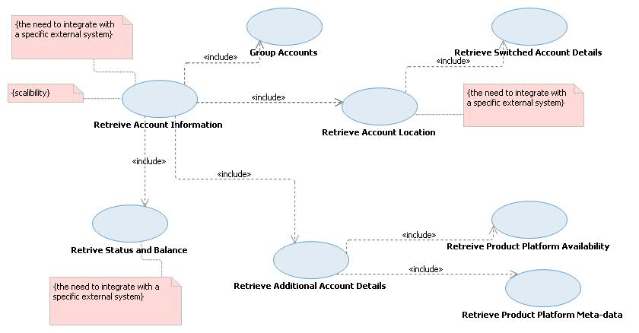

### Apply Account Posting

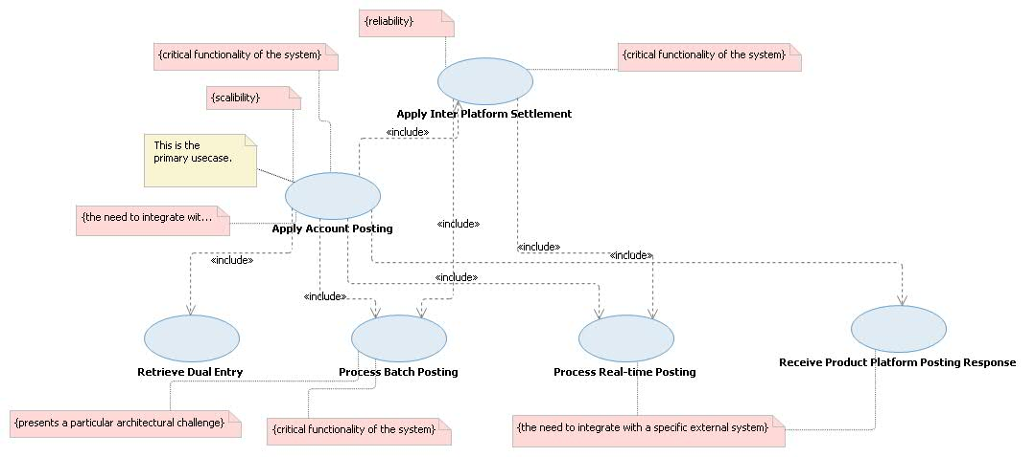Insert link to RRC project area

# 

# application view

## Outline Application View

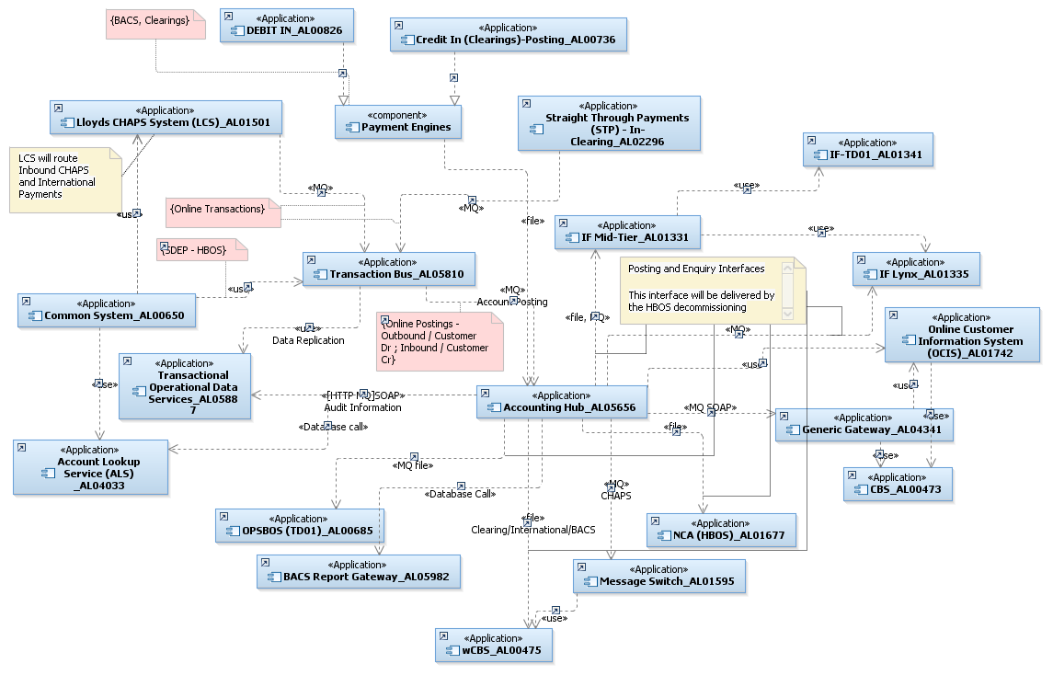

The above diagram needs to be modified after the interface discussion is complete.

The diagram above is a logical diagram showing the interfaces from Accounting hub. Account Master data is considered to be part of accounting hub.

Accounting hub can be split within two major applications. (1) Accounting Hub Services and (2) Account Master data

Accounting Hub services – provide two capabilities account enquiry and account posting. The posting is split as on-line and batch. For online it will primarily be an MQ message (SOAP/non-SOAP), for batch Accounting hub will generate posting files for the product platforms.

Accounting hub will build a File processing module in Java, using a cluster-aware file processing frameworks. Accounting hub Services will mark the delivery mode as file. The file processing module will generate the posting file for the platform. If Accounting hub receives a bulk file with posting entries Accounting hub File processing module will split the files into individual entries and bulk it by platform. This will allow us to have a single file containing all postings for a platform. Reversals and rejects can be handled and removed from posting.

This section describes the architecturally significant parts of the design model, such as its decomposition into subsystems and mapping to applications and services. It also provides a way of validating that no significant subsystems have been missed by illustrating a static test of the **key** Use Cases in Sequence Diagrams.

If there have been changes since the Architecture Overview was finalised then update this section accordingly. Otherwise, mark as No Change.

Refer to the Outline Application Architecture instructions in the Usage Model for Application Architecture in RSA (which is available on Compass). Insert the relevant diagram into this section. See Hint and Tip RSA Diagrams – Copying or Saving.

## Detail Application View

### Account Enquiry

The following diagram shows the Account Enquiry service. Key Points

1. Account Lookup Service will resolve the hHBOS product platform. Based on configuration Accounting hub will forward the enquiry request to these product platforms.
2. Interfaces will be built from Accounting Hub to the hHBOS product platforms. These interfaces will be MQ/HTTP interfaces. This will have to be completed after the interface definition is complete.
3. AMD will cache all reference data, this will reduce load on the databases. There will be two caches setup (a) web cache to store the request/response (b) data-cache / IBM extreme scale.

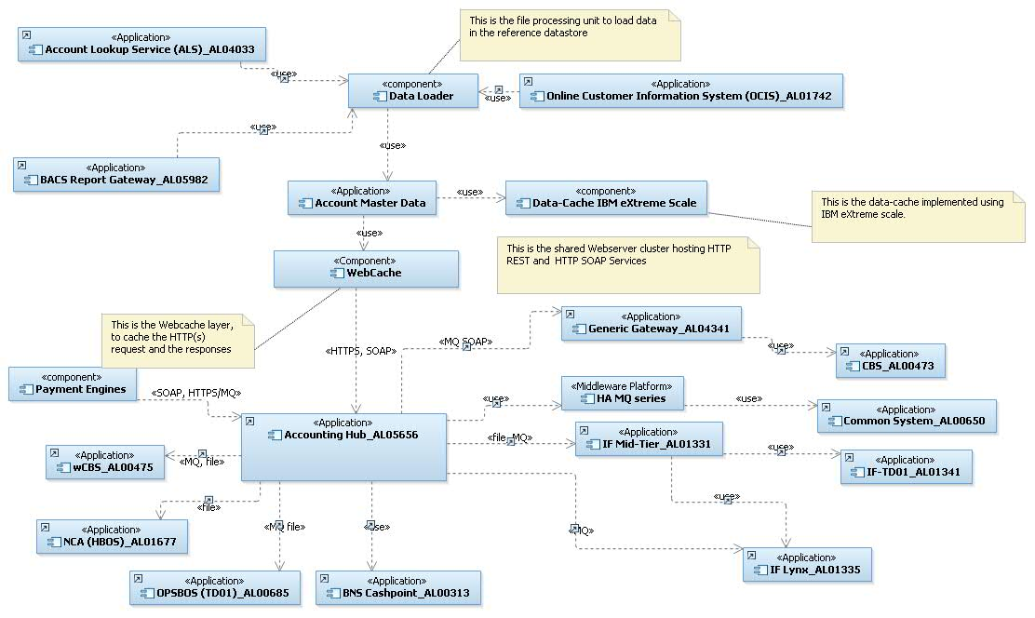

| No | Name | Interface from | Interface to | Protocol/ Transport | Message format | Interface available | Connected with Accounting hub |
| --- | --- | --- | --- | --- | --- | --- | --- |
|  | Additional Account Information | Accounting Hub | Account Master Data | HTTPS | SOAP | Yes   1. Changes will be done to the service contract. 2. AMD will provide all the product platform identifiers including rCBS/CAP/Common System | Yes |
|  | getNPADetails/ getDualEntry | Accounting Hub | Account Master Data | HTTPS | SOAP | Yes   1. Changes will be done to the service contract. | Yes |
|  | F929/ OCIS API for Account Details | Account Master Data | OCIS | HTTP(S) | SOAP | Yes | Yes. Currently the api is directly invoked from Accounting hub Broker flows. The change is to invoke this api from AMD instead. |
|  | Data Cache  (This is a technology interface to make the query responses faster) | Account Master Data | Data Cache / IBM Extreme scale.  This is a shared infrastructure component between CODS/TODS and Accounting Hub | Native /Java call | Java Data objects | This component exists in the bank. However Account master data need check the data in the cache before the query is passed to the database. | No. This needs to be integrated. IBM Extreme scale plugin needs to be configured and code changes done to lookup the cache. |
|  | Account Enquiry 🡪 rCBS | Accounting hub | Generic Gateway 🡪 rCBS | MQ | SOAP | Yes | Yes (Already delivered as part of TMH 4) |
|  | Account Enquiry 🡪 Common System | Accounting hub | HA Gateway 🡪 Common System | MQ | XML | Yes | Yes (Already delivered as part of TMH 4) |
|  | Account Enquiry 🡪 Common System | Accounting hub | BNS Cach point | MQ | SOAP | No (Currently being delivered for TMH 5.1) | No (Currently being delivered for TMH 5.1) |
|  | Account Enquiry 🡪 IFTD01 | Accounting hub | IFTD01 | MQ | SOAP | No | No  There is no requirement for Balance and real-time status for IF accounts |
|  | Account Enquiry 🡪 IFLynx | Accounting hub | IFLynx | MQ | SOAP | No | No  There is no requirement for Balance and real-time status for IF accounts |
|  | Account Enquiry 🡪 TD01 | Accounting hub | TD01 | MQ | Fixed format | No | No  There is no requirement for Balance and real-time status for IF accounts |
|  | Account Enquiry 🡪 wCBS | Accounting hub | Message Switch 🡪 wCBS | MQ | SOAP | Yes | No  There is no requirement for Balance and real-time status for IF accounts |
|  | Account Enquiry 🡪 NCA | Accounting hub | NCA |  |  | No | No  There is no requirement for Balance and real-time status for IF accounts |

The following is the component diagram for Account Master Data services.

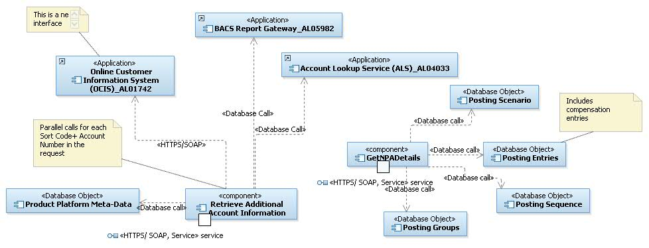

### Account Posting Flow

The following diagram shows the top level Accounting Hub Posting Components. Accounting Hub till Release TMH 4 only supports online postings. As part of HBOS Decommission Accounting Hub will have to post the posting transactions as files to the hHBOS product platforms.

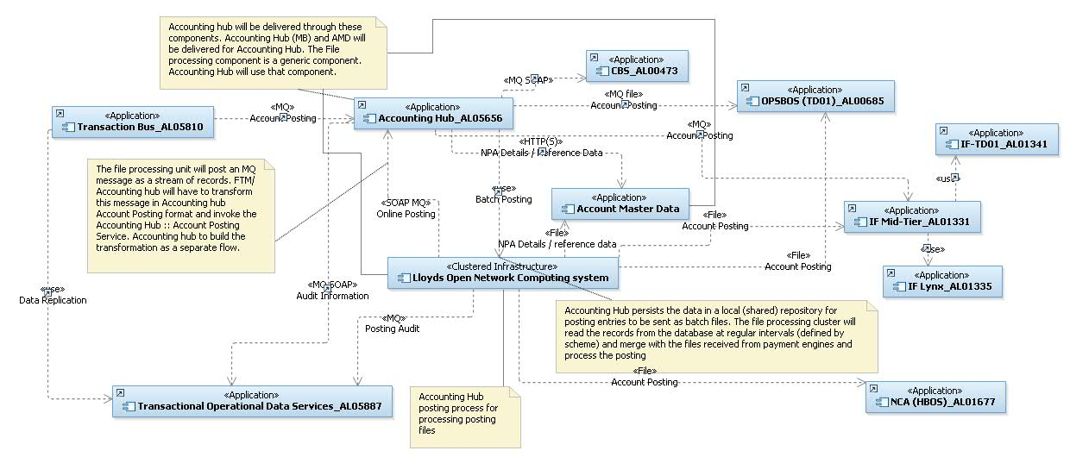

The Lloyds Open Network Computing System (LONCS) system (a.k.a File processing service) is being positioned as a generic file processing cluster for the entire bank. This will be used to process all files. Accounting hub as part of hHBOS decommissioning will use this cluster to generate posting files to the product platforms and process incoming posting files.

The Accounting Hub message broker component (AL05656) will pass entries to the file processing unit that needs to be sent to the Product platform as batch posting. During processing of a Posting file if an posting needs to be sent to a product platform as an online message the message will be generated and sent to Accounting hub Broker component. The file processing component will not be responsible to convert the message in Account Hub :: Account Posting format. The reason for not doing that is :

1. The message exchange pattern (MEP) is fire-forget / datagram within the file processing parlance. Although it is a Posting request, but the file processing service will not have any receivers. The issue of unapplied will be handled as a separate process within Accounting Hub. Please refer “Posting with No Consumer” below
2. Outbound SOAP calls will be a big overhead during the file process. There will be no business logic to handle business failures.

The message sent from File processing component to the Accounting hub will be transformed within Accounting hub, as a separate transformation flow.

### Account Posting

The following diagram shows the high level component to process the Posting entries. This contains both the file and online transactions

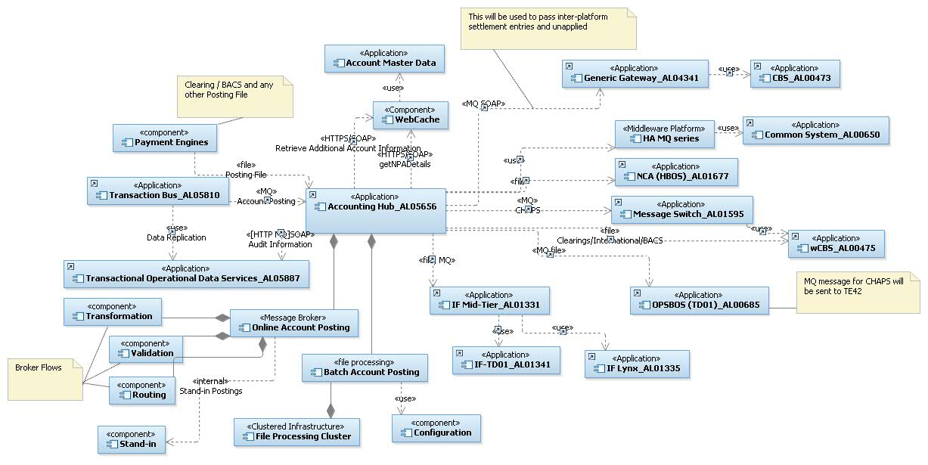

Key changes:

1. Transformation, routing and validation are pluggable components. These will be different for each interface
2. File processing component will be added to the Accounting Hub. Different Jobs and Tasks will be created for each file interface (inbound and Outbound)
3. Stand-in will have to be implemented as the Accounting hub will support inbound postings
4. Interfaces to the hHBOS platform.

| Payment Scheme | Platform | Options | Interfacing Platform | Mode | Message Format | Notes |
| --- | --- | --- | --- | --- | --- | --- |
| CHAPS | wCBS | 1 | Message Switch AL01595 | Message | SPA | Accounting Hub can use the Message switch interface to post CHAPS postings to wCBS. Accounting Hub can use SPA message format to send a message to Message Switch.  This interface can be used for faster payment postings to wCBS. |
| CHAPS | TD01 | 1 | Message Switch AL01595 | Message | SPA | If the Message switch interface with TD01 can be used then this can also be used for FPS along with CHAPS messages.  The possibility of usage of message switch is not finalized yet and needs the confirmation from TD01/Message switch SME’s |
| CHAPS | TD01 | 2 | TE42 | Message | Proprietary | If this interface has to be used for integrating Accounting Hub with TD01 then this will be more specific to CHAPS payments and can’t be used for FPS postings.  Note: In this case any requirement to post FPS payments to TD01 via Accounting Hub will have to be treated as a new requirement and the project team will have to deal with it. |
| CHAPS | IFTD01/IFLynx | 1 | IF-Midtier | Message | Proprietary | If this interface has to be used for integrating Accounting Hub with IF-Midtier (IFTD01/IFLynx) then this will be more specific to CHAPS payments and can’t be used for FPS postings.  Note: In this case any requirement to post FPS payments to IF-Midtier( IFTD01/IFLynx) via Accounting Hub will have to be treated as a new requirement and the project team will have to deal with it. |
| CHAPS | IFTD01/IFLynx | 2 | IF-Midtier | File | Proprietary | If this interface has to be used for integrating Accounting Hub with IF-Midtier (IFTD01/IFLynx ) then this will be more specific to CHAPS payments and can’t be used for FPS postings.  Note: In this case any requirement to post FPS payments to IF-Midtier (IFTD01/IFLynx ) via Accounting Hub will have to be treated as a new requirement and the project team will have to deal with it. |
| CHAPS | IFTD01/IFLynx | 3 | Message Switch AL01595 --> IF-Midtier | Message | SPA | If the Message switch interface with IF-Midtier can be used then this can also be used for FPS along with CHAPS messages.  The possibility of usage of message switch is not finalized yet and needs the confirmation from IF-Midtier /Message switch SME’s |
| CHAPS | NCA | 1 | NRT Proxy - AL04340 | Message | SPA | This option has been ruled out by NCA SME (Isabel Taggart).NCA accept only files. |
| CHAPS | NCA | 2 | Direct | File | Proprietary | This is the only option to interface with NCA via NRT proxy. |
| International | wCBS | 1 | Direct | File | AK350 | Done |
| International | TD01 | 1 | Direct | File | Proprietary | We need more information on the format. Copy book shared. URBIS format |
| International | IFTD01/IFLynx | 1 | Direct | File | Proprietary | We need more information on the format |
| International | NCA | 1 | Direct | File | Proprietary | We need more information on the format |
| Clearings | wCBS | 1 | Direct | File | AK350 | Done |
| Clearings | TD01 | 1 | Direct | File | Proprietary | We need more information on the format. Copy book shared |
| Clearings | IFTD01/IFLynx | 1 | Direct | File | Proprietary | We need more information on the format |
| Clearings | NCA | 1 | Direct | File | Proprietary | We need more information on the format |
| BACS | wCBS | 1 | Direct | File | AK350 | Done |
| BACS | TD01 | 1 | Direct | File | Proprietary | To be decided |
| BACS | IFTD01/IFLynx | 1 | Direct | File | Proprietary | To be decided |
| BACS | NCA | 1 | Direct | Message | Unknown | Mapping to be completed |
| FPS | wCBS | 1 | Message Switch AL01595 | Message | SPA | Mapping to be completed |
| FPS | TD01 | 1 | Message Switch AL01595 | Message | SPA | Mapping to be completed |
| FPS | IFTD01/IFLynx | 1 | IF-Midtier | Message | SPA | Mapping to be completed |
| FPS | NCA | 1 | Message Switch AL01595 --> IF-Midtier | Message | SPA | Mapping to be completed |

**Posting to wCBS :**

Accounting Hub will be posting CHAPS/International/BACS/Clearings/FPS payments types to wCBS .

Accounting Hub will build the interface with wCBS for file and MQ based postings.

Currently FPS postings to wCBS go via Message Switch .STP sends these postings in SPA format to message switch and then message switch posts to wCBS using AK350 format.

Accounting Hub will use the same route as FPS for CHAPS postings to wCBS .AHUB will send the SPA format posting request message(Online MQ message) to message switch for CHAPS payment types. Message switch then will post this to wCBS using AK350 format.

For International/BACS/Clearings AHUB will send the file in AKFM350 format directly to wCBS.

**Postings to IFTD01/IFLynx :**

All postings to IFTD01/IFLynx goes via IF-Midtier. Currently FPS postings to IF platform goes via Message switch .STP sends it in SPA format to message switch and then message switch post it to IF-Midtier. IF-Midtier separate out the postings for current/saving accounts and accordingly send it to IFTD01 or IFLynx .

Accounting Hub can utilize the message switch route to post to IF platforms as an online MQ message for CHAPS payment postings.

For International/BACS/Clearings AHUB will send the file to IF-Midtier.

Note: The message switch route for CHAPS has to be confirmed by the IF/Message Switch SME’s. Only after the confirmation we can finalize this interface.

The following diagram shows the posting state model. The proposal is not to design based on a fixed accounting model. Hence the data from getNPA will drive the posting entries.

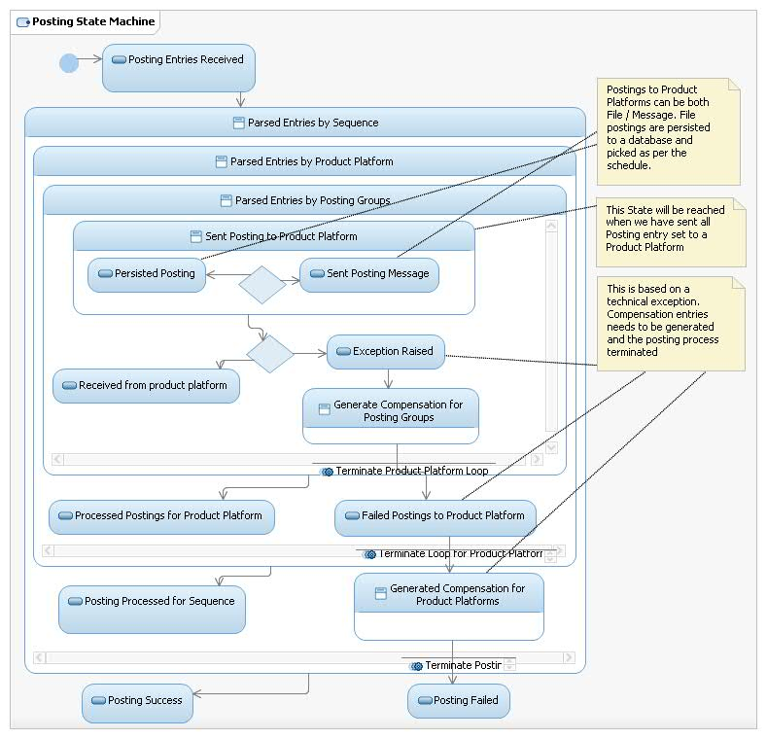

**Posting with no Consumer:** This is a scenario where there is no payment engine owning the posting flow. Accounting Hub:: Account Posting will have to include a flag to identify there will be no consumer for the response. The account posting response will be logged in Accounting hub and in the event of failure a business event will be generated. The event generation is a feature of TODS and Accounting hub will reuse this feature. This feature will be further explored by the Payment stream projects as they would have more concrete business requirements around unapplied processing, the [ayment engine projects will have to identify the necessary events and agree with TODS. In the event of unapplied posting Accounting hub can post to a NPA if the data is configured within AMD::GetNPA. The process would terminate when the response (after the compensation) is persisted within the database.

### Process Batch Posting

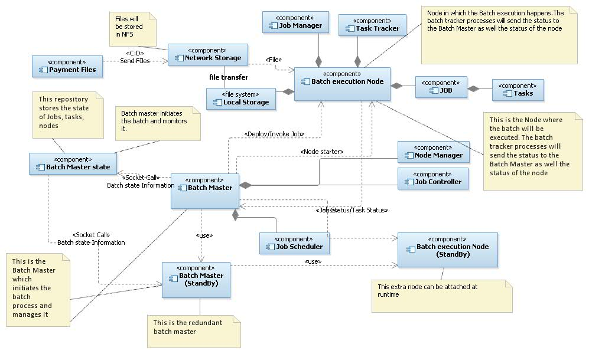

The solution is highly distributed and self-healing. The Batch Master decides the node the Job is to be run. The decision is done at runtime based on the availability of the nodes. The Job Scheduler runs the schedule. For every Job there needs to be a schedule and the Job meta-data configured. The Job meta-data and the schedule will be stored in the Batch Master State (repository) will be store the Job Schedule and the Job Meta-data. The Job Meta-data will primarily contain Job requirements (no of threads, memory etc). Once the Job starts the Batch Master State Repository will start maintaining the state of the Job. The Job State, will be continuously sent from the Batch Execution Node and the same will be persisted in the repository. If the Batch Master fails the standby Batch Master will continue the process from the state stored in the repository.

The nodes (Batch Master, and the Batch Execution Nodes) in the cluster will communicate over a secured channel. The Job will be submitted to a Batch Execution Node by the Batch Master. The Job will be deployed on the Batch Master as an archive file. The archive file will be transmitted to the node where the Job will be run. Batch Master will maintain the list of available Jobs in each of the Batch Execution Nodes, this will reduce the archive file transmission before starting a Job.

The input data will be split and transferred to multiple nodes in the cluster, this is to run the Job in parallel. The Job Meta-data must define the splits required, and the logic of splitting. This split is not for individual records in a file, but this is for the file as a whole. Although the expectation is to have more parallel tasks, but based on the nature of processing there will be need for Steps in the Job to be run in a single threaded mode (aka reducer tasks). In that case the preceding tasks in one for multiple nodes will have to finish before the single threaded task will be started. The data created by the previous steps will be transferred to the Batch Execution Node where this Single threaded task will be run. As a meta-data for the Step it will be classified to run as either parallel or as a single threaded mode.

Based on the Job submitted to a Batch Execution Node the Job will fetch the files required for processing to its local storage. Once the Job/Step/Task finishes and there is a physical write task to a file, the file will be transferred to the central Network File Storage location.

Each Batch Execution Node is Job agnostic, hence any Job can be run on any Node. This allows us to add / remove nodes from the cluster. Once a Node Joins the cluster, it broadcasts it status to the Batch Master, which accepts the Node in the cluster. Once the Node is accepted in the cluster the Batch Master can use the node for the next Job in Job queue. The Batch execution Nodes can vary in terms of physical capacity, based on the physical capacity and the Job requirements and the current Jobs running on a node the Jobs will be queued to a Node.

The Batch Master will have control to restart a Job in another node instance either because the Node processing the Job has failed or the Node has lost connection with the Batch Master. Even if the Node comes back up, or the Node joins back in the cluster the Batch Master will discard any results from that Node.

The task will be sub-divided into the following:

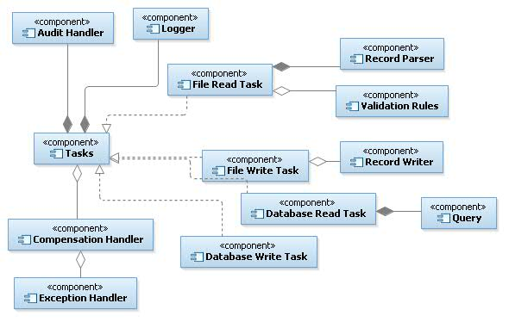

Each of the tasks will have to be built for a particular file process. Group of tasks will make a step. The approach is to avoid any outbound calls to any external hosted service as part of a task. This does not exclude database reads / writes. Database bulk insert/update and read must be provisioned. However the database activity must either be done before the file processing commences or after the file processing completes. Data must be exported from the database and created as files. These files will be used to do a join.

For example, for a posting file to be processed there will be a step to sort the file by product platform. The product platform will have to be resolved. There must be a separate step to create a file with sortcode + account number and product platform. This file will have to be an outer Join to identify the product platform. If a the product platform cannot be identified. The record needs to be rejected and exception raised. These exceptions will have to be collated in a separate file.

There must be a task to partition the records by keys, for example a separate file needs to be created by each product platform.

There must be a separate task to transform the records by destination format. This will be rule based. The transformation rules will have to be loaded in the distributed cache.

Every Job, Step and Task will have common logging and auditing points. These must be wireable through configuration settings for a particular job.

**File processing patterns**

| Pattern Name | Possible Steps | Tasks | Notes |
| --- | --- | --- | --- |
| Inbound Posting File  (Payment engines 🡪 Accounting Hub 🡪 Product Platforms) | Parse Record 🡪 Group Record by Sort Code/Account number 🡪 Resolve Product Platform 🡪 Group By product Platform 🡪 Create Contra Records 🡪 Split Record By Product Platform 🡪 Split Records by Type of Posting 🡪 Transform to product Platform Format 🡪 Record Audit in TODS | Parse Record  Join Record – With Product Platform Reference Data  Join Record – With Posting Data for Contra record  Filter Records – Filter for duplicate postings  Record Group Task  Transform Record - to Target Format | The inbound files may contain Posting entries which may be sent to the product platform as online messages apart from files to the product platform.  Once the records are split by product platforms each set can be processed parallel  The provision must be provided to filter records and the rejected records needs to be audited / logged for exception processing  The common Task will be to record these postings in TODS. Each individual record will be sent to TODS with the associated file reference. The TODS audit information will be for both the inbound and outbound file. |
| Generate Posting File  (Accounting Hub 🡪 Product Platform) | Retrieve Posting Entries 🡪 Group Record by Sort Code/Account number 🡪 Group By product Platform 🡪 Split Record By Product Platform 🡪 Split Records by Type of Posting 🡪 Transform to product Platform Format 🡪 Record Audit in TODS | Parse Record  Record Group Task  Transform Record - to Target Format | This scenario will be executed as an extension to the online posting process. Accounting Hub will receive the posting requests. It will resolve the entries required to be posted to the product platforms. A particular Product platform may want some/ all entries to be sent as batches. In that event Accounting Hub online process will complete the online posting request after the entries (to be posted as file) are posted to a database. A scheduler will trigger which will have a retrieve task. This task will retrieve the posting records from the database and trigger the Job.  The common Task will be to record these postings in TODS. Each individual record will be sent to TODS with the associated file reference. The TODS audit information will be for both the inbound and outbound file. |
| Reference Data files  (Platforms 🡪 Accounting Hub : AMD) | Parse Record 🡪 Group Records 🡪 Create CheckPoint 🡪 Post Records | Parse Record  Load Record | This Job will load the reference data files in a database. |

The main task for the file processing to work is to identify mutually exclusive record sets and group records based on a criteria. These must be configurable by Job.

The processing can be done for files having header and trailer records. These records may have fields to be added to each detail record. In that case the header record fields must be cached in the Job Context.

RAMDAS : REVIEW THE TODS SERVICE

## Sequence Diagrams for all Use Cases

### Apply Account Posting (hHBOS)

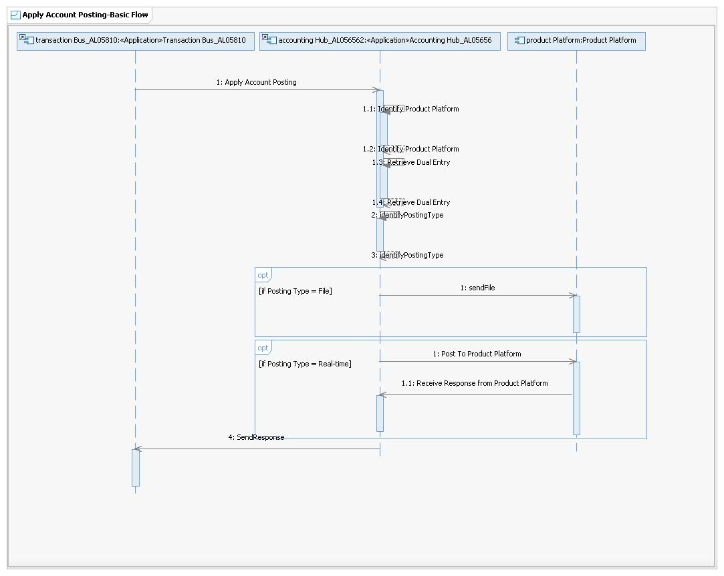This section illustrates how the end-to-end system is expected to work by giving all of the architecturally significant use case (or scenario) elaborations and explains how the various outline design model elements contribute to their functionality.

Sequence diagrams should be provided for **all** **architecturally significant** use cases referenced in section to demonstrate how the model elements will interact. This enables the requirements for all of the Components indicated in the previous section to be validated. See Hint and Tip RSA Diagrams – Copying or Saving.

Note: Audit data to TODS for files will be sent from Accounting hub

### Apply Inter Platform Settlement

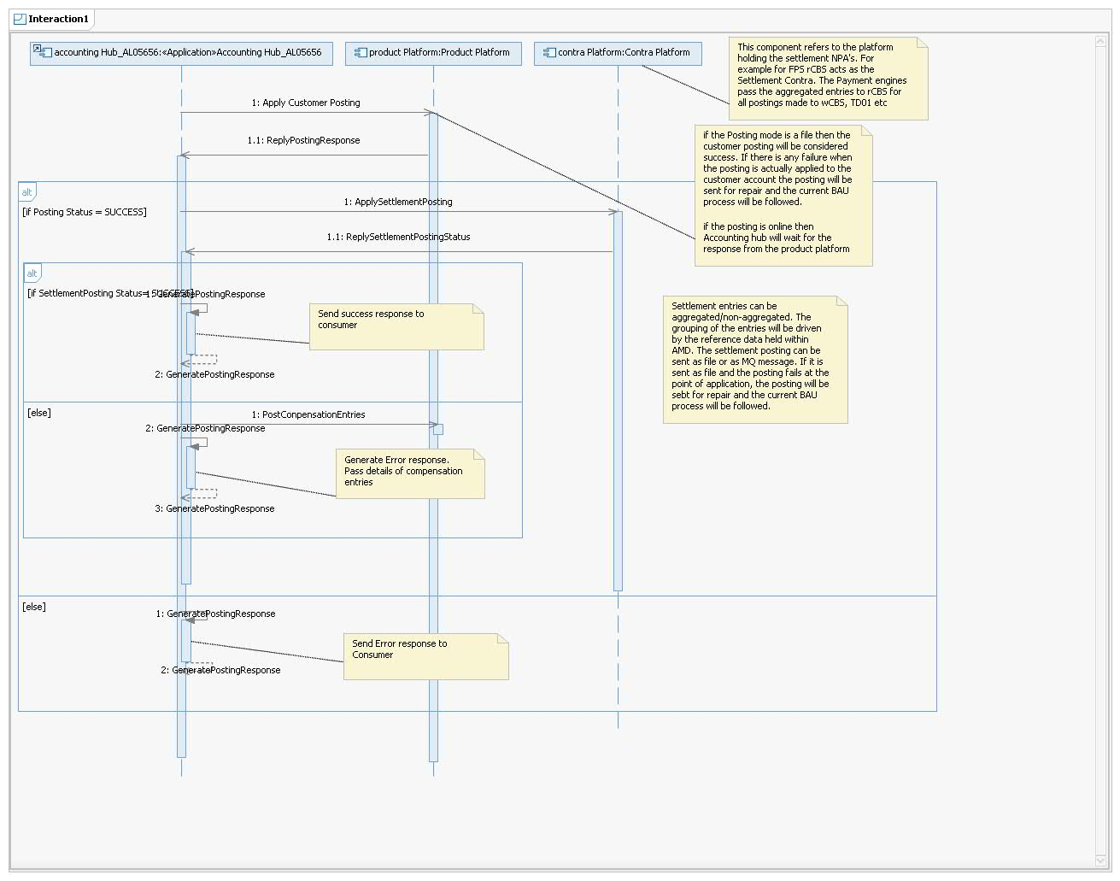

# Data View

This section describes the persistent data storage for the system. If there is little or no persistent data or the translation between the Design Model and the Data Model is trivial then that must be stated.

## Outline Data Elements

Refer to the Outline Data Architecture instructions in the Usage Model for Information Architecture in RSA (which is available on Compass).

Insert the relevant diagram into this section. See Hint and Tip RSA Diagrams – Copying or Saving.

Highlight whether there will be significant new or increased data movement between systems in this solution especially if that movement is to or from systems which are outside the project’s system boundary.

## Detail Data Elements

Refer to the Detail Data Architecture instructions in the Usage Model for Information Architecture in RSA (which is available on Compass).

Insert the relevant diagram into this section. See Hint and Tip RSA Diagrams – Copying or Saving.

# Infrastructure View

This section describes at a high level the network and hardware configurations on which the software is deployed and run. It is a view of the Deployment Model.

## Outline Infrastructure Elements

Refer to the Outline Infrastructure Architecture instructions in the Usage Model for Infrastructure Architecture in RSA (which is available on Compass).

Insert the relevant diagram into this section. See Hint and Tip RSA Diagrams – Copying or Saving.

* + 1. **Outline Infrastructure Impact**

Update the Infrastructure impact table with the relevant infrastructure impacts as described in the Outline Infrastructure Impact guidance on Compass. Mark all rows “Not Applicable” if not impacted.

| **Technical Platform** | **Sub-Platform** | **Impact** | **Comments** |
| --- | --- | --- | --- |
| Mainframe | IBM System z - zOS |  |  |
| IBM System z - Linux |  |  |
| Unisys - Dorado OS2200 |  |  |
| Unisys - Libra MCP |  |  |
| Teradata - Linux |  |  |
| HP Nonstop - Guardian |  |  |
| Mid-range | System p - AIX |  |  |
| Sun - Solaris |  |  |
| System I - O/S i5 |  |  |
| HP Itanium - HP-UX |  |  |
| x86 Server | x86 - Linux |  |  |
| x86 - Windows |  |  |
| Appliance | DataPower |  |  |
| Black box |  |  |
| Role | Presentation (Internet) |  |  |
| Presentation (Intranet/Portal) |  |  |
| Application Hosting |  |  |
| Database |  |  |
| File Serving |  |  |
| Collaboration Services |  |  |
| Directory Services |  |  |
| Centralised Printing/Scanning |  |  |
| Client | Head Office |  |  |
| Branch |  |  |
| Hybrid (Head Office-Branch) |  |  |
| Application Hosting (Citrix) |  |  |
| Desktop Hosting (VMware VDI) |  |  |
| Local Printing/Scanning |  |  |
| Network | WAN |  |  |
| Data centre LAN |  |  |
| Office/Branch LAN |  |  |
| 3rd Party Links |  |  |
| Telephony |  |  |
| Internet / DMZ |  |  |
| Systems and Service Management | Software Distribution - Client |  |  |
| Software Distribution - Server |  |  |
| Patch Management |  |  |
| Job Scheduling |  |  |
| Remote Control |  |  |
| File Transfer |  |  |
| OS Monitoring and Alerting |  |  |
| Business Availability Monitoring |  |  |
| Synthetic End to End Monitoring |  |  |
| Real End User Monitoring |  |  |
| Dependency Mapping |  |  |
| Application Monitoring and Alerting |  |  |
| Storage & Backups | IBM Enterprise Storage |  |  |
| HP EVA |  |  |
| Hitachi Storage |  |  |
| NetBackup |  |  |
| TSM Backup |  |  |
| EMC Centera |  |  |
| NetApp |  |  |
| Data centres | Horizon Centre |  |  |
| Peterborough |  |  |
| West Yorkshire |  |  |
| Distributed Tech Room |  |  |
| Treasury & Markets |  |  |
| Scottish Widows (Edinburgh) |  |  |
| Europe |  |  |
| North America |  |  |
| Asia |  |  |
| 3rd Party External |  |  |

## Detail Infrastructure Elements

Refer to the Detail Infrastructure Architecture instructions in the Usage Model for Infrastructure Architecture in RSA (which is available on Compass) Ensure, at this stage, that ALL impacted service components and stack elements are in Troux and the Infrastructure related elements are either accurate or that the project is addressing their update. .

Insert the Physical Topology diagram into this section. See Hint and Tip RSA Diagrams – Copying or Saving.

* + 1. **Detail Centralised Infrastructure Impact**

| **Service Component** | **Quantity** | **Project Impact** | **Initial Hosting Decision** | **Final Hosting Decision** | **Pattern** | **Sub-Pattern** | **Hardware Variance to Policy and Patterns** | **Software Variance to Policy and Patterns** |
| --- | --- | --- | --- | --- | --- | --- | --- | --- |
|  |  |  |  |  |  |  |  |  |
|  |  |  |  |  |  |  |  |  |

* + 1. **Detail Client Infrastructure Impact**

| **Service Component** | **Quantity** | **Project Impact** | **Initial Hosting Decision** | **Final Hosting Decision** | **Pattern** | **Hardware Variance to Policy and Patterns** | **Software Variance to Policy and Patterns** |
| --- | --- | --- | --- | --- | --- | --- | --- |
|  |  |  |  |  |  |  |  |
|  |  |  |  |  |  |  |  |

* + 1. **Detail Network Infrastructure Impact**

| **Network Component** | **Project Impact** | **Location** | **Type** | **Quantity/Scale** | **Pattern** | **Standard** |
| --- | --- | --- | --- | --- | --- | --- |
| Wide Area Networking (WAN) |  |  |  |  |  |  |
| Local Area Networking (LAN) |  |  |  |  |  |  |
| Network Services (IP Address Management, DNS, DHCP, NTP) |  |  |  |  |  |  |
| Network Security Infrastructure |  |  |  |  |  |  |
| End User (Office and Branch) Voice and Video |  |  |  |  |  |  |
| Contact Centre Telephony |  |  |  |  |  |  |
| *If required, provide further supporting context and background here* |  |  | | | | |

* + 1. **Detail Systems Management Impact**

| **Component** | **Platform (OS/Appliance)** | **Location** | **Type** | **Quantity/ Scale** | **Application/ System/ Service/**  **Business Process** | **Pattern** | **Standard** | **Project Impact** |
| --- | --- | --- | --- | --- | --- | --- | --- | --- |
| Software Distribution - Client |  |  |  |  |  |  |  |  |
| Software Distribution - Server |  |  |  |  |  |  |  |  |
| Patch Management |  |  |  |  |  |  |  |  |
| Job Scheduling |  |  |  |  |  |  |  |  |
| Remote Control/Access |  |  |  |  |  |  |  |  |
| OS Monitoring and Alerting |  |  |  |  |  |  |  |  |
| Infrastructure Monitoring and Alerting |  |  |  |  |  |  |  |  |
| Infrastructure Application Monitoring |  |  |  |  |  |  |  |  |

* + 1. **Detail Service Management Impact**

| **Application, System, Service, or Business Process Name** | **Dependency Mapping (Number of Hosts)** | **Synthetic Monitoring** | **Real User Monitoring** | **Business Application Monitoring** | **Business Transaction Monitoring** | **Message Catalogue Updates** | **OLA and SLA Reference** |
| --- | --- | --- | --- | --- | --- | --- | --- |
|  |  |  |  |  |  |  |  |
|  |  |  |  |  |  |  |  |

* + 1. **Detail Storage Impact**

| **Service Component** | **Project Impact** | **Hardware Platform** | **Location** | **Requested Initial Allocation** | **% Expected Growth** | **Pattern or Standard** | **System Availability** | **Performance Required** | | **Data Archiving Cutoff** | **Replication** |
| --- | --- | --- | --- | --- | --- | --- | --- | --- | --- | --- | --- |
| Standard or High | Connectivity (2,4 or 8) |
|  |  |  |  |  |  |  |  |  |  |  |  |
|  |  |  |  |  |  |  |  |  |  |  |  |

* + 1. **Detail Storage Back-up Impact**

| **Service Component** | **Project Impact** | **Platform** | **Frequency** | **Retention** | **Backup Window** | **Initial Backup Size** | **% Daily Change** | **LAN Free, LAN or remote/WAN** | **SNAP** | **Replication** |
| --- | --- | --- | --- | --- | --- | --- | --- | --- | --- | --- |
|  |  |  |  |  |  |  |  |  |  |  |
|  |  |  |  |  |  |  |  |  |  |  |

* + 1. **Detail Messaging and Collaboration Impact**

| **Component** | **Impact** | **Recipient and Users** | | **Volume** | **Pattern** | **Standard** | **Frequency and Schedule** |
| --- | --- | --- | --- | --- | --- | --- | --- |
| EMail |  |  | |  |  |  |  |
| EMail Journaling |  |  | |  |  |  |  |
| Instant Messaging |  |  | |  |  |  |  |
| File Share |  |  | |  |  |  |  |
| SharePoint Applications |  |  | |  |  |  |  |
| Intranet |  |  | |  |  |  |  |
|  | | **Source** | **Target** |  | | | |
| File Transfer |  |  |  |  |  |  |  |
| FAX |  |  |  |  |  |  |  |
| Automated SMTP |  |  |  |  |  |  |  |

## 

## Environment Overview

Complete the following table in accordance with the guidance available. Further information about the Environment Overview is available [here](http://hbos.intranet.local/gito/adf/COMPASS2/DesignArtefactPages/Environment%20Overview.aspx).

|  |  |  |  |  |
| --- | --- | --- | --- | --- |
| **Environment Category** | **Route to Live Environment Name** | **Environment Use** | **Project Impact** | **Description** |
| Development / Local Test | DEV1 |  |  |  |
| DEVn |  |  |  |
| Formal Test | TEST1 |  |  |  |
| TEST2 |  |  |  |
| TESTn |  |  |  |
| Pre-Production | TEST0 |  |  |  |
| NFT |  |  |  |
| Production | PROD |  |  |  |
| DR |  |  |  |
| Other | N/A |  |  |  |

# Cross-Cutting views

If there have been changes since the Architecture Overview was finalised then update this section accordingly. Otherwise, mark as No Change.

## Security

Highlight any architecturally significant areas of change or concern in the Security View

### Security Domain Impact Analysis

|  |  |  |  |
| --- | --- | --- | --- |
| **Affected Security Domain** | **Impact Description (change / new / no impact)** | **Level H/M/L** | **Probability  Likely / Known** |
| Infrastructure Security | No Impact |  |  |
| Identity Management | No Impact |  |  |
| Application Security | No Impact |  |  |
| Fraud and Financial Crime | No Impact |  |  |
| Information Privacy | No Impact |  |  |
| Compliance | No Impact |  |  |

### Security Model for Impacted Domains

Required if there are impacted security domains; otherwise not applicable.

Outline the security problem or refer to the relevant requirements and illustrate the solution that will address the impacted security domains. See Hint and Tip RSA Diagrams – Copying or Saving.

* + 1. **Detail Infrastructure Security**

|  | **Question** | **Response** |
| --- | --- | --- |
| **Managed File Transfer** | | |
| 1a | Provide details of the end systems involved in the file transfer. |  |
| 1b | What file transfer mechanisms are being used in the solution?  (Delete those not applicable) | Connect Direct (CD)  Connect Direct Secure plus (CD+)  Secure FTP (FTPS)  Secure Shell File Transfer Protocol (SFTP)  Secure HTTP (HTTPS)  Other (please describe) |
| 1c | Indicate the type of transfer:  (Delete those not applicable) | Business to Business (B2B External)  Application to Application (A2A Internal)  Other (please describe) |
| 1d | Is a file transfer hub/staging server being used?  If no go to 1i | Yes/No |
| 1e | Is MEFG being used as the file transfer hub?  If no go to 1g | Yes / No |
| 1f | Indicate which other MEFG security services are being used:  (Delete those not applicable)  Go to 1h | Encryption of data at rest (PgP):  Non-Repudiation  E-mail notifications  Audit logging and Secure audit trails  Other (please describe) |
| 1g | Provide details of the staging server being used. |  |
| 1h | Please provide details of the end to end file transfer solution as follows:  Internal system to/from file transfer hub:  External system to/from file transfer hub: | {Describe the FT protocol in use, see 1}  {Describe the FT protocol in use, see 1} |
| 1i | Describe the authentication mechanisms being used (Bank to third party and third party to Bank):  (Delete those not applicable) | UserID/Password  Secure Token  Digital Certificates  Active Directory  LDAP  Other (please describe) |
| 1j | Please provide details of the direction of the transfer:  (Delete those not applicable) | Third party initiates connection and pushes file to Bank  Third party initiates connection and pulls file from Bank  Bank initiates connection and pushes file to 3rd party  Bank initiates connection and pulls file from 3rd party. |
| **Remote Access VPN** | | |
| 2a | Is this third party remote access to the Bank?  If yes go to 2c | Yes / No |
| 2b | Is this Lloyds Banking Group client systems, accessing 3rd party services?  If yes go to 2i | Yes / No |
| 2c | Is the solution based on the Juniper SSL VPN service?  If no go to 2e | Yes / No |
| 2d | Which Juniper SSL VPN features are being used?  (Delete those not applicable)  Go to 2h | Netconnect  Windows Secure Access Method (WSAM)  Java Secure Access Method (JSAM)  Core Access  Host Checker  Secure Virtual Workspace (SVW)  Other (please describe) |
| 2e | Is this a point to point VPN solution?  If no go to 2g | Yes / No |
| 2f | Confirm the point to point VPN tunnelling solution in place?  (Delete those not applicable)  Go to 2h | IPsec Firewall to Firewall  IPsec router to router  Other (please describe) |
| 2g | Describe the key components of the solution, and the security interactions between components. |  |
| 2h | Describe the authentication mechanisms being used (Lloyds Banking Group to third party and third party to Lloyds Banking Group):  (Delete those not applicable) | UserID/Password  Secure Token  Digital Certificates  Active Directory  LDAP  Other (please describe) |
| 2i | Provide details of the remote system and internal target systems and the type of access required. | |
| **Network Zoning Solutions** | | |
| 3a | Describe the reason for establishing a new network zone e.g. BIA assessment, regulatory requirements, policy compliance, standard architecture solution. | |
| 3b | List the type of zone(s) being established? | |
| 3c | Provide details of the mechanisms being used to implement the zone(s) e.g. Firewall, VLAN’s {including specific infrastructure details if possible e.g. PBZ AS}. | |
| 3d | Describe the ingress and egress traffic flow requirements for each zone. This should include ports, protocols, purpose and details of the traffic direction i.e. which system initiates the connection. | |
| **Security Event Detection** | | |
| 4a | Is this solution using existing security event detection solutions?  (Delete those not applicable) | IDS  IPS  HIDS  Other (please describe) |
| 4b | Is this solution deploying any new security event detection mechanisms?  (please provide details) | |

## Identity Management

|  | **Question** | **Response (delete as applicable)** |
| --- | --- | --- |
| 1 | Where are the user credentials stored?  (Delete those not applicable) | Active Directory  ADAM  Other LDAP  SQL Database  Oracle Database  DB2 Database  Other (please specify) |
| 2 | Where are the User Entitlements stored?  (Delete those not applicable) | ADAM  Other LDAP  SQL Database  Oracle Database  DB2 Database  Other (please specify) |
| 3 | What method will be used for the addition of new users?  (Delete those not applicable) | ILAS  Order IT  OIM  ILM/MIIS Application specific  Other Feed  Other Manual |
| 4 | Approximately how many new users will be added? | |
| 5 | How many user roles are there within the application? | |
| 6 | Please list the entitlement groups. | |
| 7 | What data determines a user’s entitlements to the application?  (Delete those not applicable) | Grade  Role  Department  Line Manager  Cost Centre Manager  Location  Other |
| 8 | List any other data items that are used to determine a users entitlements to the application and provide the items source where known. | |
| 9a | Does the Application use single sign-on?  If No, go to question 10a | Yes / No |
| 9b | If Yes, what SSO method is used?  (Delete those not applicable) | Windows integrated  Unix to Windows via BMC  Unix to Windows native Kerberos  Desktop SSO  Identity Federation (e.g. ADFS/SAML)  Other |
| 9c | If answered Other to 9b, please describe the SSO method used. | |
| 9d | If answered Other to 9b, what other SSO methods does the application support? | |
| 10a | Does the Application store the user’s logon-id?  If No, go to question 11. | Yes / No |
| 10b | If the logon-id is stored, in what format is it stored?  (Delete those not applicable) | Fully Qualified (Domain\user-id)  User-id only  Other |
| 10c | If the logon-id is stored, does the application assume the logon-id is the same as the user's HR employee ID? | Yes / No |
| 10d | What is the maximum length of logon-id that can be stored? | |
| 10e | Must the logon-id be of fixed length? | Yes / No |
| 10f | What is the format of the logon-id?  (Delete those not applicable) | Numeric only  Alpha only  Alphanumeric (any mix)  Alphanumeric (fixed format)  Not applicable |
| 10g | Can the application distinguish between cases in the logon-id e.g. is all the processing of logon-ids case sensitive? | Yes / No |
| 11a | Does the application store its own passwords?  If No, go to question 12 | Yes / No |
| 11b | What form of encryption is used on stored passwords?  (Delete those not applicable) | None  Oneway hash  Key based encryption  Other (please specify) |
| 12 | Provide any further information or document references that may help to identify information that can be used to automatically provision users to this application. | |
| 13 | Will this service or application be on boarded to use the ARP service for recertification? If not, provide full details of the recertification solution to be used. | |

## Application Security

|  | **Question** | **Response** |
| --- | --- | --- |
| 1 | What Application to Application Authentication mechanisms are used in the solution?  (Delete those not applicable) | Not applicable in this solution  SSL Mutual Auth  WS-Security (state which token type)  IPSEC  Other (please specify solution and rationale) |
| 2a | Is Security mediation (Datapower) used in the above?  If “No” to 2a, please go to 3. | Yes / No |
| 2b | If “Yes” to 2a, describe the service consumers and service providers and their respective security mechanisms? | |
| 3 | How does the application authenticate itself to the database?  (Delete those not applicable) | Not applicable in this solution  Windows Integrated Authentication  Windows Integrated Authentication with Service Principal Names (constrained delegation/secure channel)  SQL Server mixed mode (app uses a Windows account)  SQL Server mixed mode (app uses a SQL account – e.g. username password in connection string)  Oracle Wallet  Other (please specify solution and rationale) |
| 4 | What mechanism is used to perform database queries? | N/A - no sql statements are used by the application  Parameterised Stored Procedures (with no dynamic sql statement construction within the stored procs)  Dynamic SQL (SQL statements dynamically constructed by the application and executed)  Other (please specify solution and rationale) |
| 5 | Which data validation techniques are used?  (Delete those not applicable) | Not applicable in this solution  Presentation – client-side Javascript  Presentation – server-side  Webservice – XML Schema validation (how and where?)  Webservice – within application logic  Webservice – no validation  Parameterised Stored Procedures |
| 6 | Are there any known vulnerabilities within the application e.g. as a result of previous penetration tests?  List all that apply. (including  their respective criticality ratings if available). | Not applicable in this solution  SQL Injection  Cross Site scripting  Cross Site Request Forgery  Forced Browsing (URL Manipulation)  Other (please specify solution and rationale) |
| 7 | Does the solution employ a Web Application Firewall?  (Delete those not applicable) | Not applicable in this solution  Imperva, Landing Zone deployment  Imperva, other deployment - Please give the rationale  Datapower - Please give the rationale  Microsoft URLScan (entry-level “pseudo WAF”) - Please give the Rationale  Other (please specify solution and rationale) |
| 8 | How does the application perform Audit Logging (Application level events such as make a payment)?  (Delete those not applicable) | Not applicable in this solution  Local syslog  NT Event log  Application-specific database  Loglogic  Other (please specify solution and rationale) |
| 9 | What Authentication and Authorisation industry standards are used by the application?  (Delete those not applicable) | Not applicable in this solution  JAAS  SAML  XACML  Other (please specify solution and rationale) |
| 10 | How does the application propagate identity to downstream services?  (Delete those not applicable) | Not applicable in this solution  SOAP headers (Lloyds Banking Group proprietary)  SOAP headers (SAML)  Other (please specify solution and rationale) |
| 11 | Does the solution involve the introduction or amendment of an external-facing web application, mobile app or web service ? | **No** / Not applicable in this solution  **Yes**- Application vulnerability testing will be required, including: - ADM Static and Dynamic Application Security testing tools (when available) - An application penetration test (to be commissioned by the project) |
| 12 | Does the solution consume external web services? If so how?  (Delete those not applicable) | **No** / Not applicable in this solution  DataPower in Controlled Zone  Other (please specify solution and rationale) |
| 13 | Does the solution involve the introduction or amendment of an *internal* facing enterprise web application with a BIA rating of High?  (Delete those not applicable) | **No** / Not applicable in this solution  **Yes**- Application vulnerability testing will be required, including: - ADM Static and Dynamic Application Security testing tools (when available) - An application penetration test (to be commissioned by the project)  **Yes**- Application vulnerability testing will NOT be required (describe rationale below) |

+Note: lower level system security events not handled by the application e.g. log on, would be covered by Compliance domain

## Fraud and Financial Crime

The questions below are to give a framework to detail the fraud and financial crime impact of this project. Additional details can be added to any of the responses sections as required.

|  |  |
| --- | --- |
| **Fraud and Financial Crime** | |
| Does the project   * impact the Bank’s ability to detect, prevent or manage fraud and financial crime? * increase the Bank’s exposure to fraud and financial crime? | No – Please describe why not  Yes – Please give an overview **and** complete questions below |

| **Question Number** | **Question** | | **Response** |
| --- | --- | --- | --- |
| **Data** | | | |
| 1 | Does the system hold large volumes of customer data? | | Yes  No |
| 2 | Does the system hold card data (Also see PCI DSS Section)?  (Delete those not applicable) | | High Volume ( > 499 )  Low Volume ( < 500 )  No |
| 3 | Does the system process or transport Card Data (Also see PCI DSS Section)?  (Delete those not applicable) | | Yes as Merchant  Yes as Issuer  No |
| 4 | Processes Payments (Also see PCI DSS Section)? | | Yes  No |
| **Interfaces** | | | |
| 5 | Does the application feed or directly interact with Anti Money Laundering (AML) services?  (Delete those not applicable) | | CAML  Other (Please state)  No  Comments: |
| 6 | Does the Application feed or directly interact with Sanctions services?  (Delete those not applicable) | | Fircosoft  Other (Please state)  No  Comments: |
| 7 | Does the application feed or directly interact with Politically Exposed Persons (PEPs) services?  (Delete those not applicable) | | Yes (Please state)  No  Comments: |
| 8 | Does the application feed or directly interact with Application Fraud services?  (Delete those not applicable) | | SIRA  Hunter / Hunter 2  Detect  CIFAS  Other (Please state)  No  Comments: |
| 9 | Does the application feed or directly interface with Network or Link Analysis tools?  (Delete those not applicable) | | Detica  Detica – Insurance Fraud Bureau  Other (Please state)  No  Comments: |
| 10 | Does the application feed or directly interact with Transactional Fraud services?  (Delete those not applicable) | | CCTM  Falcon  Carracker Fraudlink (cheque)  RSA eVision  Other (Please state)  No  Comments: |
| 11 | Does the application feed or directly interact with Staff Activity Monitoring (SAM) services?  (Delete those not applicable) | | SAM  Other (Please state)  No  Comments: |
| 12 | Does the application feed or directly interact with Operations Platform for case management?  (Delete those not applicable) | | PEGA  CFD AS400  Adeptra  FCMS  Workflow Mgr  SIRA  EUC  Other (Please state)  No  Comments: |
| **PCI DSS (only if Yes to any of questions 2,3,4)** | | | |
| Does PCI DSS impact the project? | | No – Please describe why not  Yes – Please complete questions below | |
| 1 | Is the project part of a Group Wide PCI DSS remediation programme? | | Yes  No |
| 2 | Does the design contain a specific statement regarding the PCI DSS status on completion?  If so where? | | Yes – please detail the location  No |
| 3 | Describe how the project restricted the use of Card Data to a in the design. | |  |
| **PCI DSS please include the Architectural Overview Diagram highlighting systems and interfaces that contain Card Data** | | | |

## Information Privacy

| **Qtn No** | **Question** | **Response**  **\* delete as appropriate** |
| --- | --- | --- |
| 1 | Based on the data classification matrix – describe the volumes of data that the system handles and any transformations that the data undergoes. | |
| 2a | Does the data need to be encrypted at rest?  If No, go to Q3 | Yes / No * |
| 2b | If yes, are there any constraints on the chosen algorithm? | |
| 3a | Does the data need to be encrypted in transit?  If no, go to Q4 | Yes / No * |
| 3b | If yes, are there any constraints on the chosen algorithm? | |
| 4 | Based on the BIA, does the data need to be signed/MACed? | Yes / No * |
| 5 | Describe the authentication mechanisms used to access the system: | |
| 6a | Does the system require encryption/signature/authentication keys/certificates?  If No, go to Q7 | Yes / No * |
| 6b | If yes, which system provides those keys/certificates, and what are the provisioning details of those keys and certs (e.g. algorithms, key lengths, expiry dates, hardware or software stored)? | |
| 7 | Does the system have an external (to Lloyds Banking Group) facing connection (used to determine the level of protection of keys and authentication mechanisms)? | Yes / No * |

## Compliance

| **Qtn No** | **Question** | **Response**  **\* delete as appropriate** |
| --- | --- | --- |
| **Anti-Virus** | | |
| 1a | Is this an existing supported platform?  If “Yes” to 1a, please go to 2a | Yes / No / Don’t Know * |
| 1b | If “No” or “Don’t Know” to 1a, please contact the Compliance Domain Architect to discuss further. | |
| 2a | Is this a standard platform with an existing anti-virus (AV) Solution?  If “Yes” to 2a, please go to 3a. | Yes / No / Don’t Know * |
| 2b | If “Don’t Know” to 2a, please contact the Compliance Domain Architect to discuss further. | |
| 2c | If “No” to 2a, is there a solution available for this platform? | Yes / No / Don’t know * |
| 2d | If “Yes” to 2c, please provide further information: | |
| 2e | If “No” or “Don’t Know” to 2c, please contact the Compliance Domain Architect to designing a compliance solution for this project. | |
| **Logging and Monitoring** | | |
| 3a | Is there a requirement to log or monitor this platform?  If “No” to 3a, please go to 4a. | Yes / No * |
| 3b | If “Yes” to 3a, is there an existing logging or monitoring solution which can be used? | Yes / No / Don’t Know * |
| 3c | If “Yes” to 3b, please provide further information: | |
| 3d | If “No” or “Don’t Know” to 3b, please contact the Compliance Domain Architect to designing a compliance solution for this project. | |
| **Compliance Configuration Management** | | |
| 4a | Is there a requirement for compliance configuration management as part of this project?  If “No” to 4a, please go to 5a. | Yes / No * |
| 4b | If “Yes” to 4a, is there an existing solution that can be used? | Yes / No / Don’t Know * |
| 4c | If “Yes” to 4b, please provide further information: | |
| 4d | If “No” or “Don’t Know” to 4b, please contact the Compliance Domain Architect to designing a compliance solution for this project. | |
| **Regulatory Compliance** | | |
| 5a | Are there any requirements to produce regulatory reporting?  If “No” to 5a, please go to 6a. | Yes / No * |
| 5b | If “Yes” to 5a, details should be included in the logging or monitoring section above. | |
| 5c | If “Yes” to 5a, identify the areas of compliance required: | |
| **Internal Compliance** | | |
| 6a | Are there any areas of non-compliance?  If “No” to 6a, no further information is required. | Yes / No * |
| 6b | If “Yes” to 6a, please highlight the areas of non-compliance and ensure the project follows the exemptions process. | |

## <Other Cross-Cutting Views as Required for the Project>

Refer to the Method Guidance and the definitions of cross-cutting viewpoints on COMPASS to determine whether the requirements have an architecturally significant impact on any of them.

# Architecture Decisions

Guidance about making architecture decisions can be found [here](http://hbos.intranet.local/gito/adf/COMPASS2/EAD%20Design/Architecture%20Decisions.aspx).

The tactical solution for managing architecture decisions(ADs) is to use SharePoint. Tactical templates for the required SharePoint Log can be found on the ‘Industrialised Design Templates’ page in Compass which is [here](http://hbos.intranet.local/gito/adf/COMPASS2/EAD%20Industrialised%20Design%20Pages/High%20Level%20Design%20Templates.aspx).

The log must include all the ADs that were made during the Outline Architecture Elements Phase and those which have been made during the Detail Architecture Elements Phase.

If this version of the Architecture Description is being submitted for formal approval at Quality Gate 2, all ADs are expected to be closed by the time that the document is submitted to the DACs.

The Architecture Decisions logis held on the SharePoint site here: [Insert link to project SharePoint site]

The baseline of the Architecture Decisions that aligns with the detailed architecture is stored in the project’s Supplementary Artefacts folder in Rational tools : *[Insert URL for folder]*.

# Appendices

## IT Application Landscape Overview: Application Change Inventory

Include the snapshot report from Troux, listing the applications that will be impacted by the project.

## Compliance with Lloyds Banking Group Policies and Regulatory Requirements, IT Policies, Standards and Patterns

### Compliance with Policies, Regulations, Standards and Patterns

The tactical solution for managing the required Compliance statements is in RTC and these must be reviewed with Security.

Quality Gate 2 - complete the Compliance statements in the Work Item “Package” in RTC.

#### Compliance with Lloyds Banking Group Policies and Regulatory Requirements

The Compliance statement is in the work item “Package” in RTC.

#### Compliance with Group IT Policies

A copy of the Lloyds Banking Group IT Compliance Checklist, available from the Process Templates published on the [EAD Governance (SAF)](http://teamspace.intranet.group/sites/EADGovernance/SAF/default.aspx) site, must be completed within this document, evidencing the compliance position, compliant or non-compliant and those which are not relevant to this solution.

Outline details must be provided of all areas of non-compliance with Lloyds Banking Group IT Policies. The table must be copied into the document.

A copy of the Lloyds Banking Group IT Compliance Checklist, available from the Process Templates published on the [EAD Governance (SAF)](http://teamspace.intranet.group/sites/EADGovernance/SAF/default.aspx) site, must be completed within this document, evidencing the compliance position, compliant or non-compliant and those which are not relevant to this solution.

Outline details must be provided of all areas of non-compliance with Lloyds Banking Group IT Policies. The table must be copied into the document.

|  |  |  |  |  |
| --- | --- | --- | --- | --- |
| Application Systems | Key Contact | Version | Date Approved | Compliance |
| Channels | Gary Webb /  Alan Bennett | Draft |  | Y / N / N/A |
| Customer - Applications & Data | Chris Farnworth | Draft |  | Y / N / N/A |
| IT Java Policy | Jimmy Millar | 1.1 | 09/05/12 | Y |
| Application Services | Key Contact | Version | Date Approved | Compliance |
| Application Hosting | Alan Fisher | Indicative |  | Y / N / N/A |
| LBG IT Application Interoperability Policy | Grant Macnamara | 1.1.1 | 18/09/13 | Y |
| BPM, Workflow & Imaging | Richard Frost | Indicative |  | Y / N / N/A |
| LBG IT Web Services Policy | Carl Dunk | 1.0 | 21/10/09 | Y |
| LBG IT - Open Source Software Policy | Jimmy Millar | 1.3 | 06/11/13 | Y |
| Infrastructure Components | Key Contact | Version | Date Approved | Compliance |
| LBG IT Data Centre and Technical Rooms Policy | Kevin Tribble | 2.3 | 19/03/12 | N/A |
| LBG IT Data Storage Infrastructure Policy | Neville Grigg | 2.4 | 02/05/14 | Y |
| Group IT Mainframe - System z Policy | Rob Ayres | 3.4.1 | 29/04/14 | Y |
| [LBG IT Mainframe - Unisys Policy](http://teamspace.intranet.group/sites/ITReferenceArchitecture/Published%20Artefacts/LBG%20IT%20Mainframe%20-%20Unisys%20Policy.docx) | Martin Leckebusch | 1.4.1 | 16/04/14 | N/A |
| LBG IT Policy Midrange - System i Policy | Rob Ayres | 1.2.1 | 29/04/14 | Y |
| LBG IT Midrange - Unix Policy | Rob Ayres | 2.3.1 | 29/04/14 | NA |
| LBG Voice and Data Networks - LAN IT Policy | Peter Byrne | 1.3 | 10/07/13 | N/A |
| LBG Voice And Data Networks - Network Services IT Policy | Peter Byrne | 1.2 | 11/05/11 | N/A |
| LBG Voice and Data Networks - Voice Telephony and Video IT Policy | Peter Byrne | 1.4 | 07/09/12 | N/A |
| LBG Voice and Data Networks - WAN IT Policy | Peter Byrne | 1.3 | 10/07/13 | N/A |
| LBG IT Windows Server OS Policy | Dave Riley | 1.4.2 | 12/05/14 | N/A |
| LBG IT x86-64 Server Hardware and Virtualisation Policy | Dave Riley | 1.4.2 | 12/05/14 | Y |
| LBG IT Linux Server OS Policy | Dave Riley | 1.1.2 | 09/05/14 | Y |
| Lloyds IT Active Directory Policy | Stuart Adams | 1.4 | 04/12/13 | N/A |
| LBG IT Infrastructure Hosting Policy | Rob Ayres | 1.3 | 24/01/12 | Y |
| LBG IT End User Services Policy | Stuart Adams | 0.2 | 18/05/12 | N/A |
| [Hardware and Software Currency IT Policy.docx](http://teamspace.intranet.group/sites/ITReferenceArchitecture/Published%20Artefacts/Hardware%20and%20Software%20Currency%20IT%20Policy.docx) | Ben Cooper | 5.0 | 20/05/14 | Y |
| Infrastructure Services | Key Contact | Version | Date Approved | Compliance |
| LBG IT Change Management and Service Introduction Policy | Jamie Firth | 1.2 | 21/05/13 | Y |
| Information | Key Contact | Version | Date Approved | Compliance |
| LBG IT Reporting Policy | Dave Walsh | 0.7 | 10/10/12 | N/A |
| LBG IT Data Integration ETL Policy.docx | Dave Bargeron | 2.2 | 03/04/2013 | N/A |

#### Compliance with Group IT Standards and Patterns

List all Patterns and Standards that have been used in the design, stating compliance or non-compliance and detailing the version used. Patterns and Standards can be found in the [IT Reference Architecture](http://teamspace.intranet.group/sites/ITReferenceArchitecture/default.aspx).

Where the design does not comply, complete an Lloyds Banking Group IT EA Exemption form, also available from the [EAD Governance (SAF)](http://teamspace.intranet.group/sites/EADGovernance/SAF/default.aspx) site, and submit is as a separate document to EAD Governance.

EA EXEMPTIONS MUST NOT BE EMBEDDED IN THE DESIGN DELIVERABLES.

* [LBG IT **Security** Event Log Management Logical Pattern.doc](http://teamspace.intranet.group/sites/ITReferenceArchitecture/Published%20Artefacts/LBG%20IT%20Security%20Event%20Log%20Management%20Logical%20Pattern.docx)
* [LBG IT Secure System Acquisition, Development and Maintenance Standard](http://teamspace.intranet.group/sites/ITReferenceArchitecture/Published%20Artefacts/LBG%20IT%20Secure%20System%20Acquisition%20Development%20and%20Maintenance%20Security%20Standard.docx)
* LBG [SOAP Message Standard](http://teamspace.intranet.group/sites/ITReferenceArchitecture/Published%20Artefacts/SOAP%20Message%20Standard.doc) – **To be discussed further**
* LBG [SOA Services **Security** Mediation Pattern.doc](http://teamspace.intranet.group/sites/ITReferenceArchitecture/Published%20Artefacts/SOA%20Services%20Security%20Mediation%20Pattern.docx)
* LBG IT File Transfer Security Standard
* LBG [Cryptography Code of Conduct Compliance Standard](http://teamspace.intranet.group/sites/ITReferenceArchitecture/Published%20Artefacts/LBG%20IT%20Cryptography%20CoC%20Compliance%20Security%20Standard.docx)
* LBG IT Websphere MQ Security Standard
* Infrastructure Hosting Decision Tree
  + Integration Technologies
  + Batch processing
  + Database
  + Operational Data Store
  + BI Reporting and Analytics

### Group Records Policy Compliance

| **Policy Requirement** | **Design Response** |
| --- | --- |
| Architecture, Structure and Design |  |
| Legal and Regulatory Compliance |  |
| Ownership |  |
| Security and Access |  |
| Data quality including creation |  |
| Data Integrity (includes tracking, reliability) |  |
| Physical Storage |  |
| Archiving |  |
| Data Retention (periods of time) |  |
| Data Retrieval |  |
| Destruction and Deletion |  |

## Known Architecture Risks, Assumptions, Issues and Dependencies

RAID which have a potential impact on the project must be tracked by the Project Manager in CMT. Architecture RAID items can be managed in SharePoint. Any architectural RAID which begins to impact the project must be escalated to the PM and managed on CMT. Templates for the SharePoint Logs can be found on the ‘Industrialised Design Templates’ page in Compass which is [here](http://hbos.intranet.local/gito/adf/COMPASS2/EAD%20Industrialised%20Design%20Pages/High%20Level%20Design%20Templates.aspx) and instructions on their use [here](http://hbos.intranet.local/gito/adf/COMPASS2/EAD%20Industrialised%20Design%20Pages/SharePoint%20Lists.aspx).

RAID Items that are architecturally significant are about e.g. if there is new or amended integration with external systems or internal critical systems or if the solution is dependent on a new piece of architecture that is still in design and so part of the Detailed Architecture work cannot be completed.

**It is expected that all Architecture RAID items relevant to the Architecture baseline being submitted for Quality Gate 2 approval will have been mitigated, resolved or otherwise they must be escalated to project RAID, logged in CMT and addressed in the Project Management plan.**

Quality Gate 2 – export, from the project SharePoint list, the baseline of the Architecture RAID items that aligns with your Detailed Architecture and copy and paste below.

### Risks

|  |  |  |  |
| --- | --- | --- | --- |
| Risk Type | Definition | Impact on Accounting Hub | Probability of Occurrence and mitigation |
| Maintenance Risk | The amount of change that needs to be done in order to introduce a new functionality | The application (Accounting Hub, AMD, and the File Processing) is split into the following three classes of components:   1. Kernel 2. Optional 3. Variable   Accounting hub / AMD and the File services is built on the Microkernel architecture pattern.  The frameworks used are well known in the industry and have support and maintenance contracts | Medium 🡪 Low  ( the established design governance and development checks must be followed before a maintenance fix is introduced) |
| Reliability Risk | How reliable is the application in terms of availability, recoverability or responding to technical and business faults | Accounting Hub (Message Broker component, AMD, and File Processing) is multi-instance. The code does not have any server affinity. Hence all messages can be received in all nodes and responded from all nodes. Moreover the request and the corresponding response can take different paths. There is no need to replicate session state hence we can add / remove nodes when we want without impacting the overall service. The added nodes can start to function instantaneously. If we want to increase the availability further my suggestion is to make the DR active.  The file processing component will have the framework manage the state of a job. If the job fails in a node then the framework will restart the job.  As part of this project Accounting hub will introduce a request tracking component to track messages which has been gobbled by an instance and the instance has failed before it has processed it and sent it to any product platforms. | Low  The MTBF is considered to be low doe to node agnostic nature of the design. |

### Assumptions

The assumptions are:

1. The existing interfaces on the hHBOS product Platforms will be reused without any changes.
2. Accounting hub will not have any implicit postings it will generate the posting entries based on the account model configured within AMD:GetNPA
3. The account model will be provided by the Payment engine projects. The model would have the primary as well as the compensating entries. If there are no compensating entries Accounting hub will not be able to complete the rollback of the posting transaction.
4. The Account model assumed is based on the FPS model for hHBOS. The principal entry is posted to the hHBOS Product platforms (wCBS, TD01, IF-TD01, IF-Lynx, NCA) while the settlement is passed to rCBS. The settlement is manually carried out between rCBS and the hHBOS product platforms.

### Issues

Payment engine changes are required to consume the Accounting hub Services.

### Dependencies

Payment engine projects will have to provide the NPA / Account model for each payment scenario they want to execute.

Payment engine changes to use Accounting hub will be outside the scope of this project. The Payment engines will have to be changed and the messages to accounting hub will be in Accounting hub’s format

## references

This is a complete list of all documents and artefacts referenced elsewhere in this deliverable or in the production of the deliverable.

| **Document Title** | **Version relevant to this document** | **Owner** | **Location** |
| --- | --- | --- | --- |
| Glossary |  |  |  |
| Scope Specification |  |  |  |
| Functional Requirements |  |  |  |
| Non-Functional Requirements |  |  |  |
| Prioritised Requirements List |  |  |  |
| Project RAID Log |  |  |  |
| Architecture RAID Log |  |  |  |
| Business Entity Model |  |  |  |
| Business Rules |  |  |  |
| Architecture Proof-Of-Concept output (if applicable) |  |  |  |